Supporting Information
Merging bioresponsive release of insulin-like growth factor I
with 3D printable thermogelling hydrogels

Matthias Beudert¹, Lukas Hahn^{1,2}, Anselm H.C. Horn^{3,4}, Niklas Hauptstein¹, Heinrich Sticht^{3,4}, Lorenz Meinel^{1,5}, Robert Luxenhofer^{2,6}, Marcus Gutmann¹*, Tessa Lühmann¹*

¹ University of Würzburg, Institute for Pharmacy and Food Chemistry, 97074 Würzburg, Germany

² Functional Polymer Materials, Chair for Advanced Materials Synthesis, Institute for Functional Materials and Biofabrication, Department of Chemistry and Pharmacy, Julius-Maximilians-University Würzburg, Röntgenring 11, 97070 Würzburg, Germany

³ Bioinformatics, Institute of Biochemistry, Friedrich-Alexander-Universität Erlangen-Nürnberg, Fahrstraße 17, 91054 Erlangen, Germany

⁴ Erlangen National High Performance Computing Center (NHR@FAU), Friedrich-Alexander-Universität Erlangen-Nürnberg, Martensstraße 1, 91058 Erlangen, Germany

⁵ Helmholtz Institute for RNA-based Infection Research, Josef-Schneider-Straße 2, DE-97080 Würzburg, Germany.

⁶ Soft Matter Chemistry, Department of Chemistry and Helsinki Institute of Sustainability Science, Faculty of Science, University of Helsinki, P.O. Box 55, 00014 Helsinki, Finland

Number of pages: S1–S14
Number of figures: S1–S14
Number of videos: S1
Number of tables: None

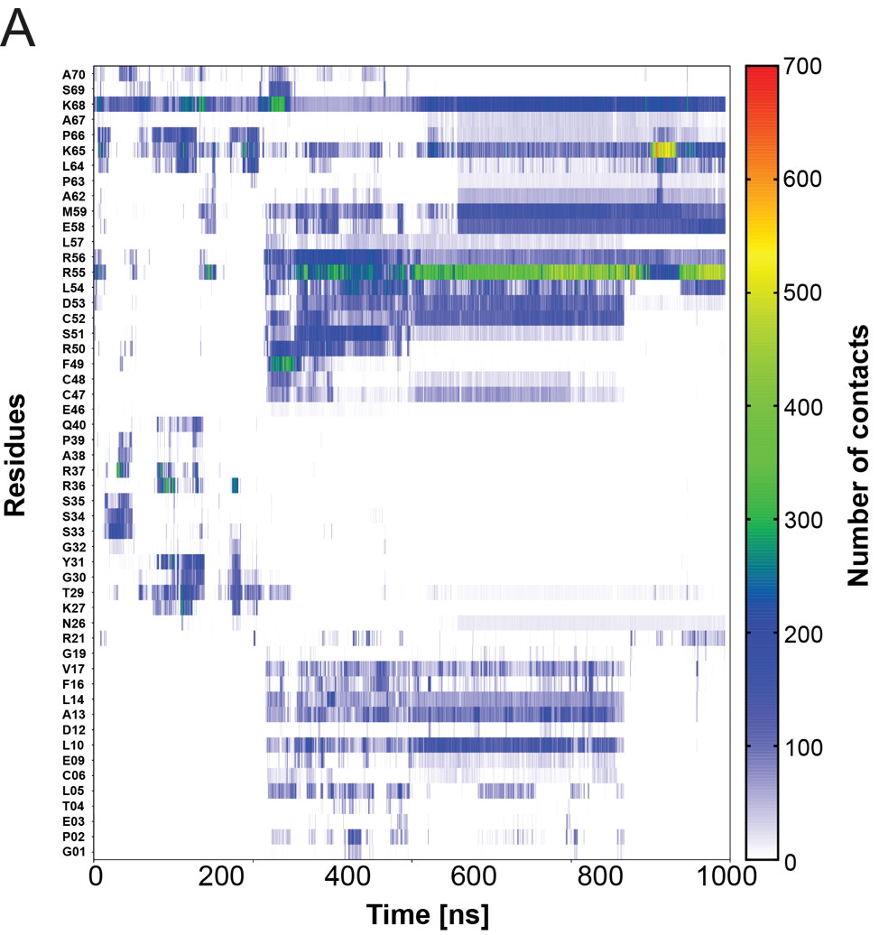
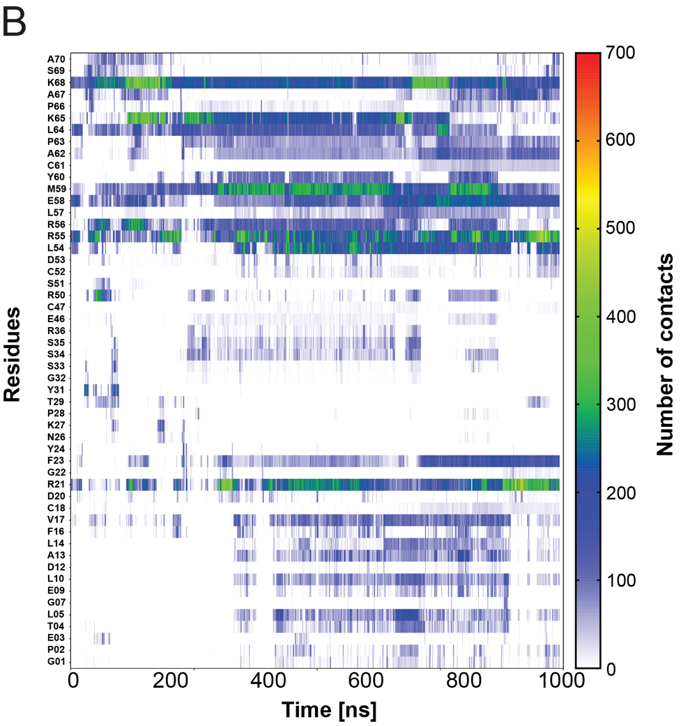
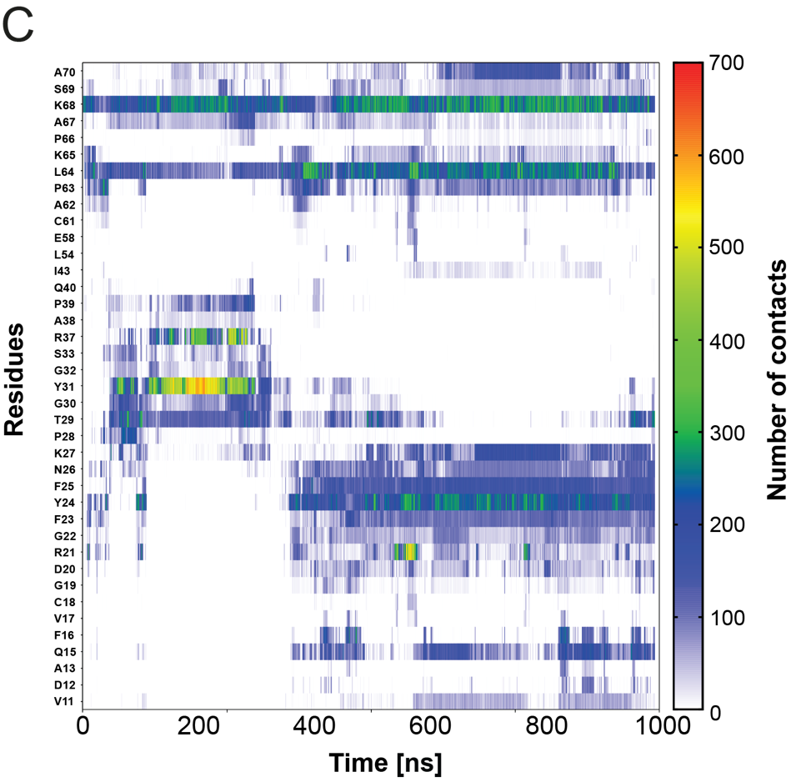
Figure S1: (A) Number of contacts between PSL and IGF-I over the simulation time (run 2). The simulation time is shown as horizontal axis and the interacting IGF-I residues on the vertical axis. (B) Number of contacts between PSL and IGF-I over the simulation time (run 3). (C) Number of contacts between PSL and IGF-I over the simulation time (run 4). The simulation time is shown as horizontal axis and the interacting IGF-I residues on the vertical axis. The number of IGF-PSL contacts is color coded (see vertical scale bar on the right).

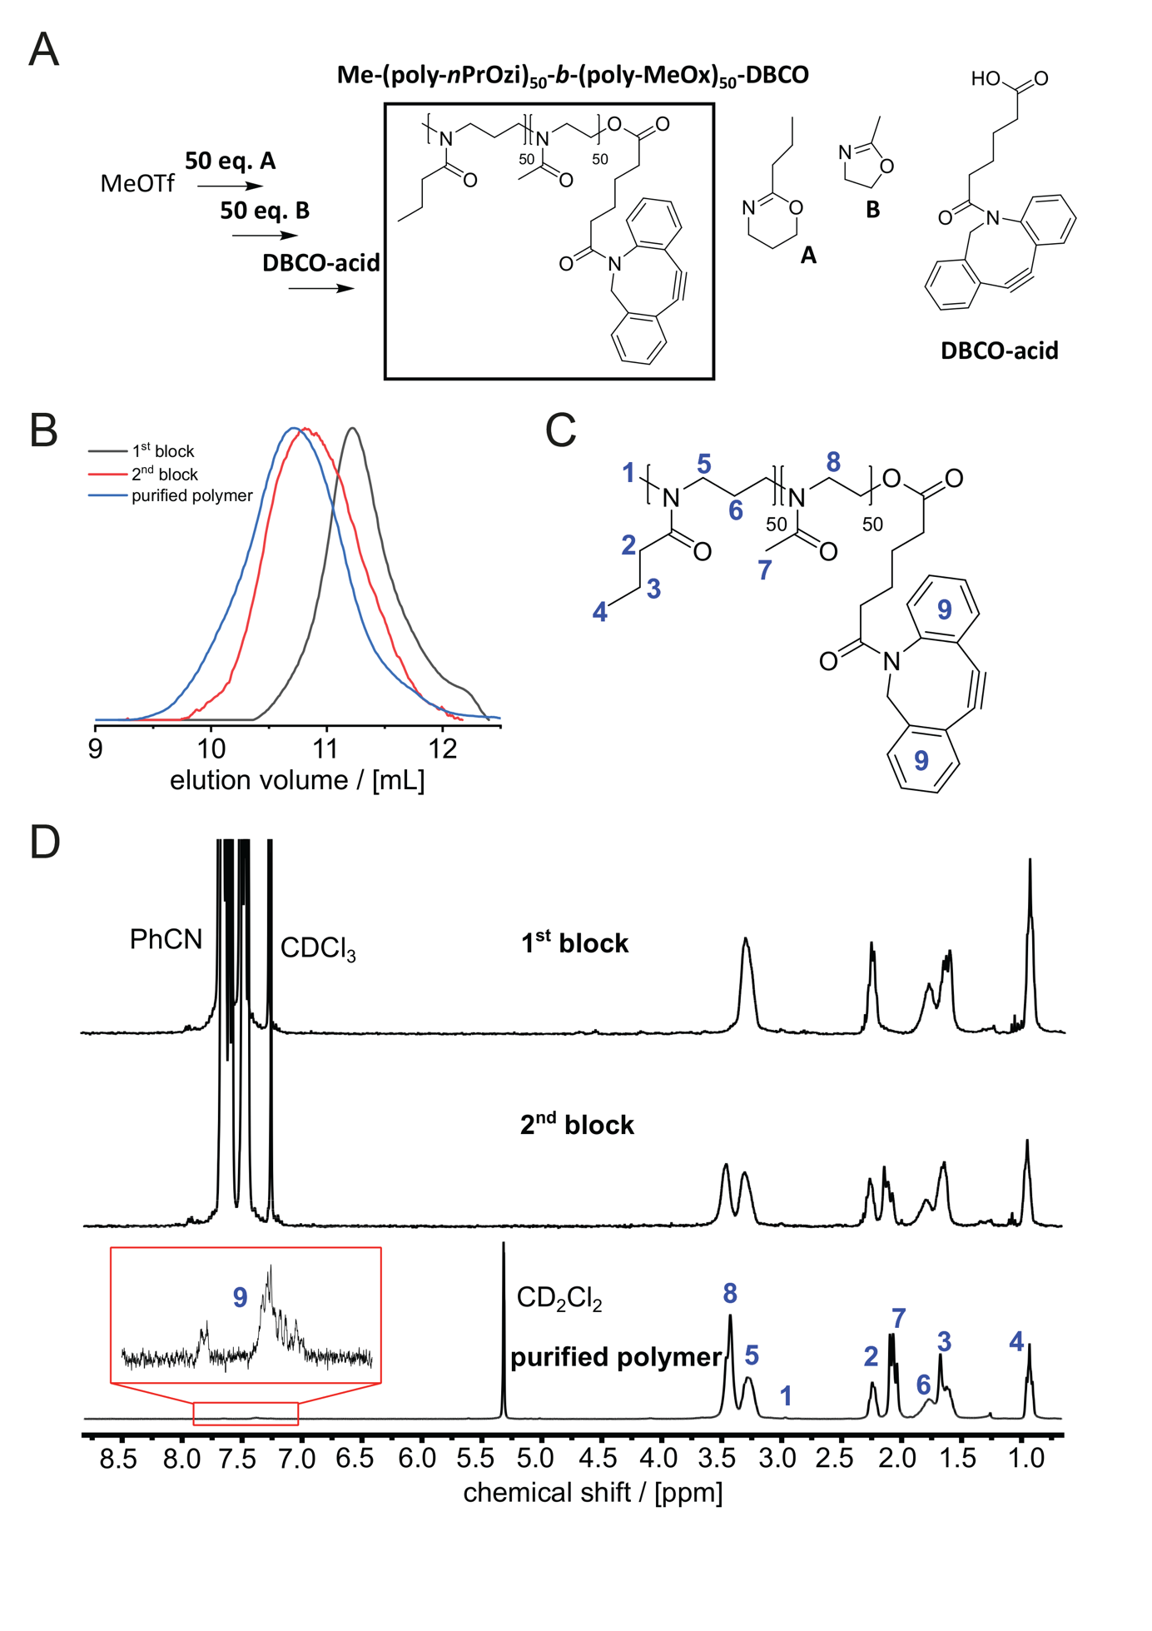
Figure S2: Synthesis and characterization of POx-b-POzi-DBCO (A) Schematic description of the synthesis of a thermoresponsive AB diblock copolymer (degree of polymerization: 100, block ratio: 1:1) comprising the thermoresponsive A block (poly-nPrOzi), the hydrophilic B block (poly-MeOx) and a DBCO omega functionality. (B) Following the reaction process via GPC. (C) Chemical structure of the AB diblock copolymer with the assignment of all relevant peaks in ¹H NMR experiments. D) ¹H NMR spectra after the 1st, 2nd block and the purified polymer.

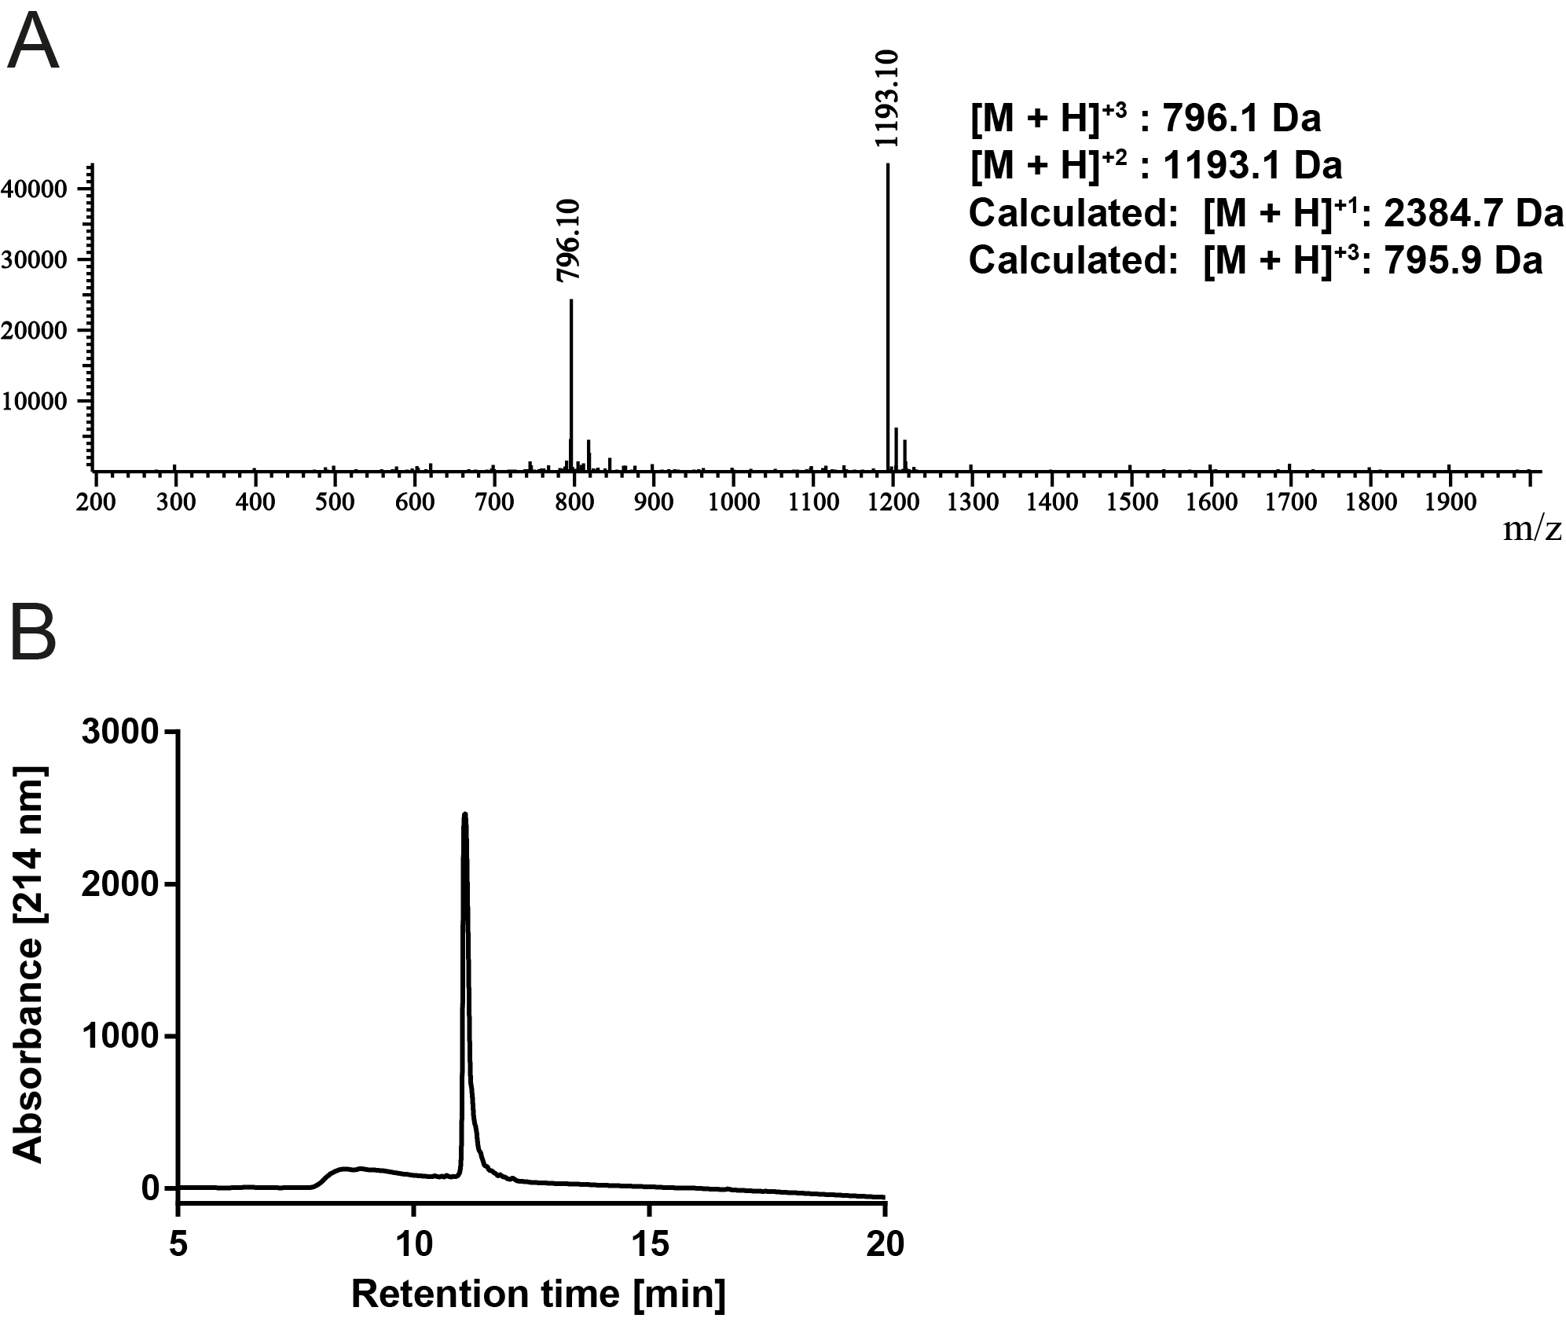
Figure S3: Characterization of PSL peptide. (A) ESI-MS analysis. (B) Purity of the peptide analyzed by HPLC.

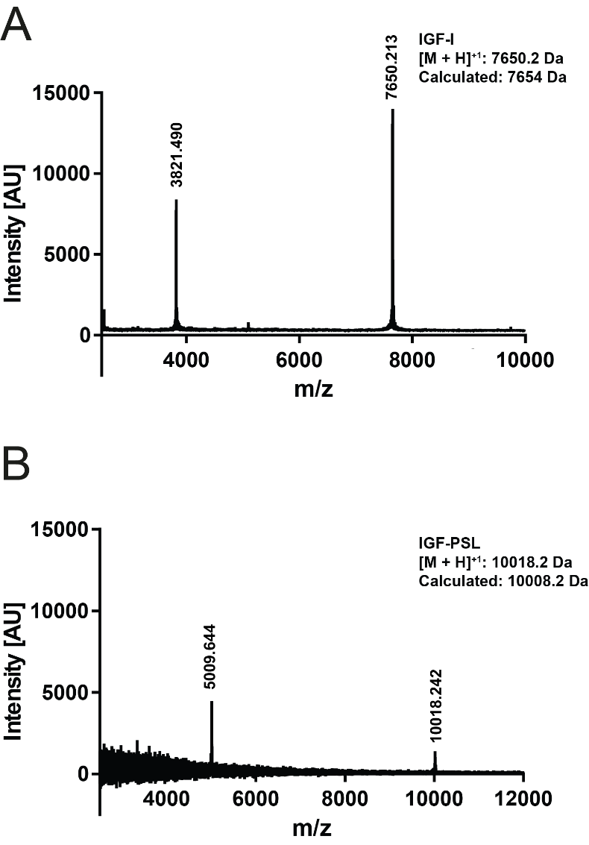

Figure S4: MALDI-MS analysis of (A) IGF-I and (B) IGF-PSL.

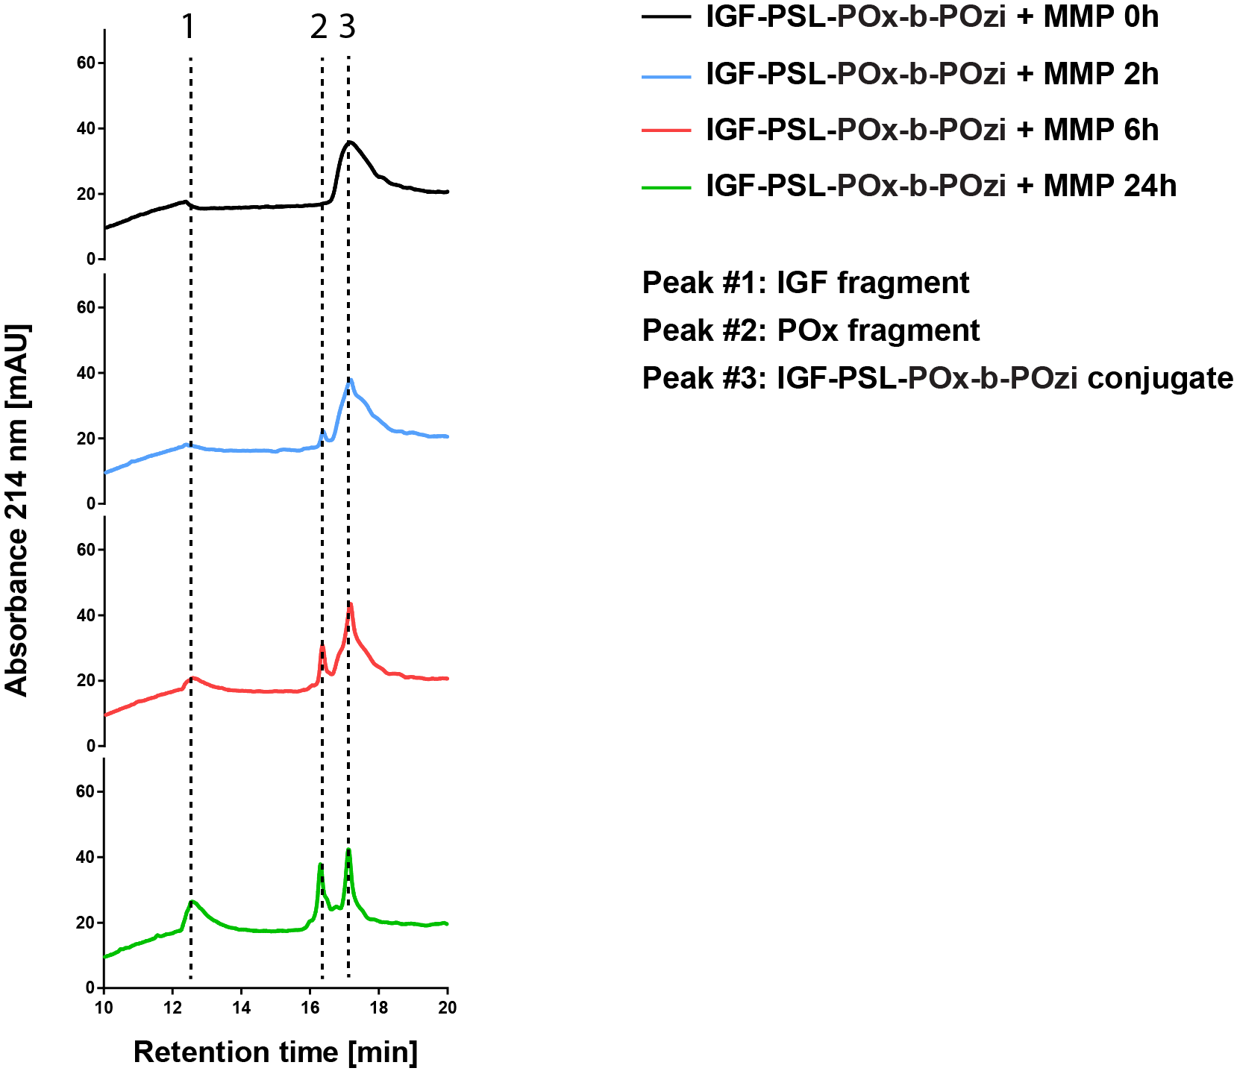

Figure S5: HPLC chromatograms of IGF-PSL-POx-b-POzi incubated with 8 nm MMP-9 at different time points.

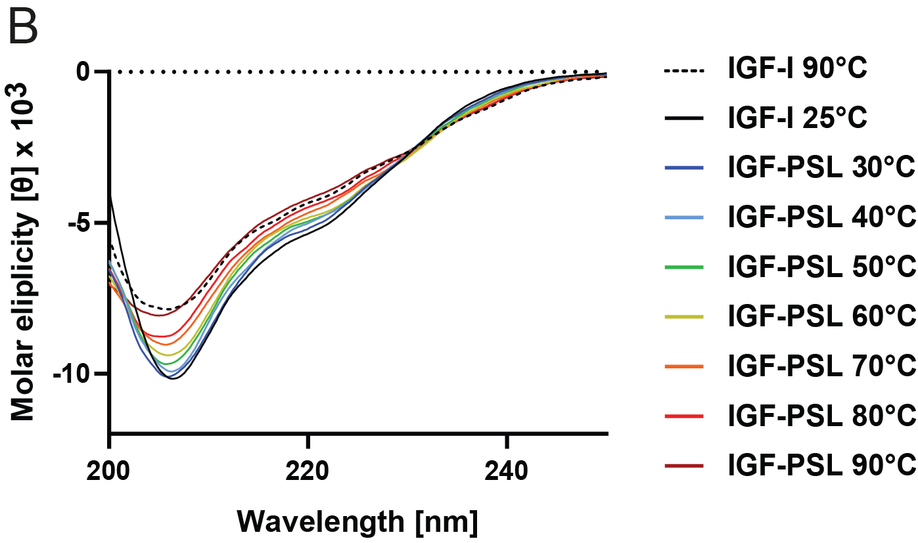

Figure S6: CD spectra of IGF-I (25 °C and 90 °C) and IGF-PSL at different temperatures ranging from 30 to 90 °C.

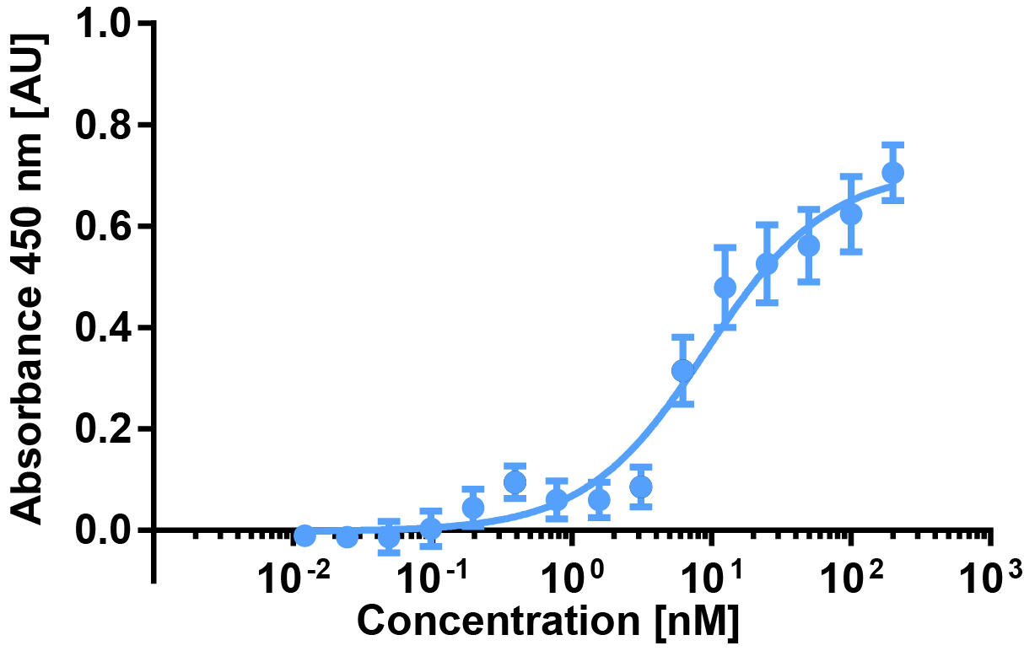

Figure S7: C2C12 myoblast proliferation assay with IGF-PSL (n=3 biological replicates and n=3 technical replicates).

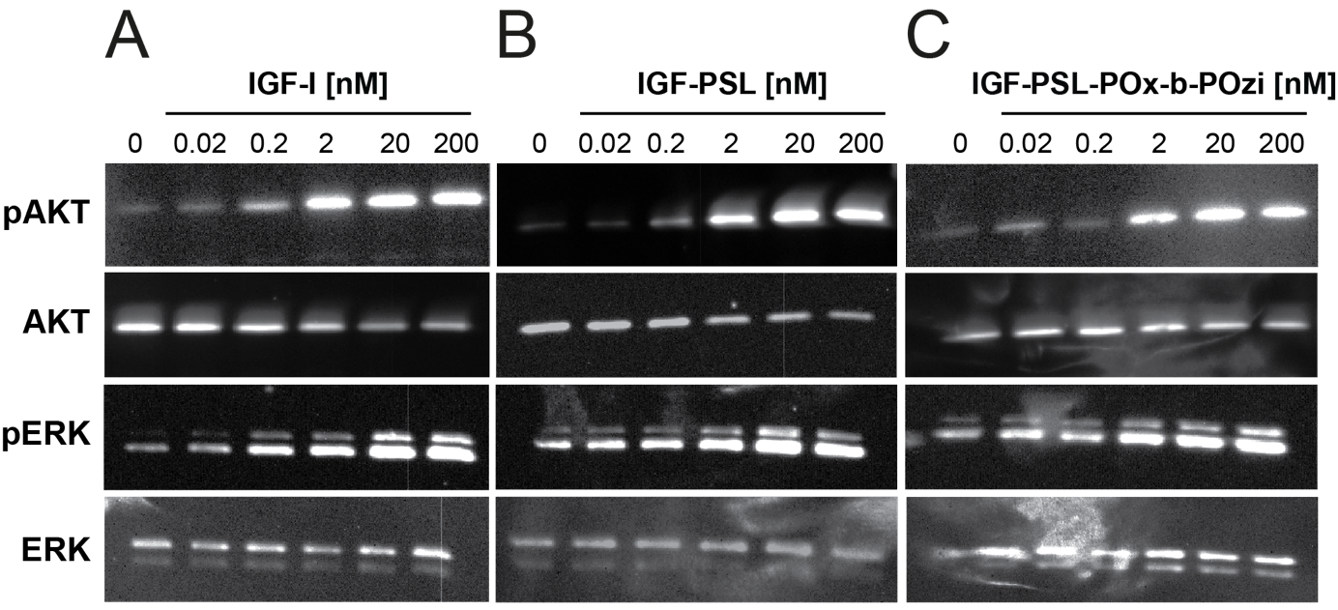

Figure S8: Bioactivity of IGF variants using western blot analysis of AKT and ERK phosphorylation in C2C12 myoblasts after exposure to (A) IGF-I, (B) IGF-PSL and (C) IGF-PSL-POx-b-POzi.

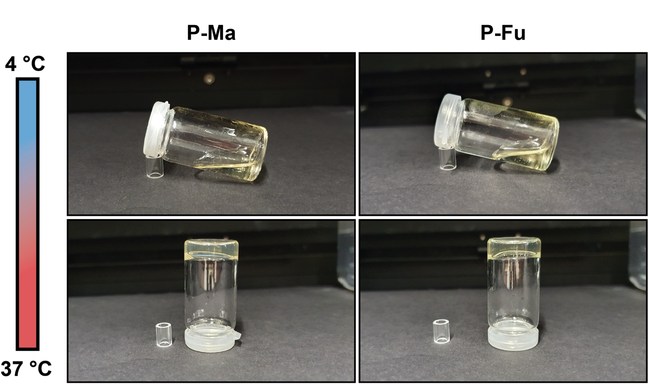

Figure S9: Thermogelling properties of the different modified polymers. P-Ma and P-Fu at 4 °C and RT.

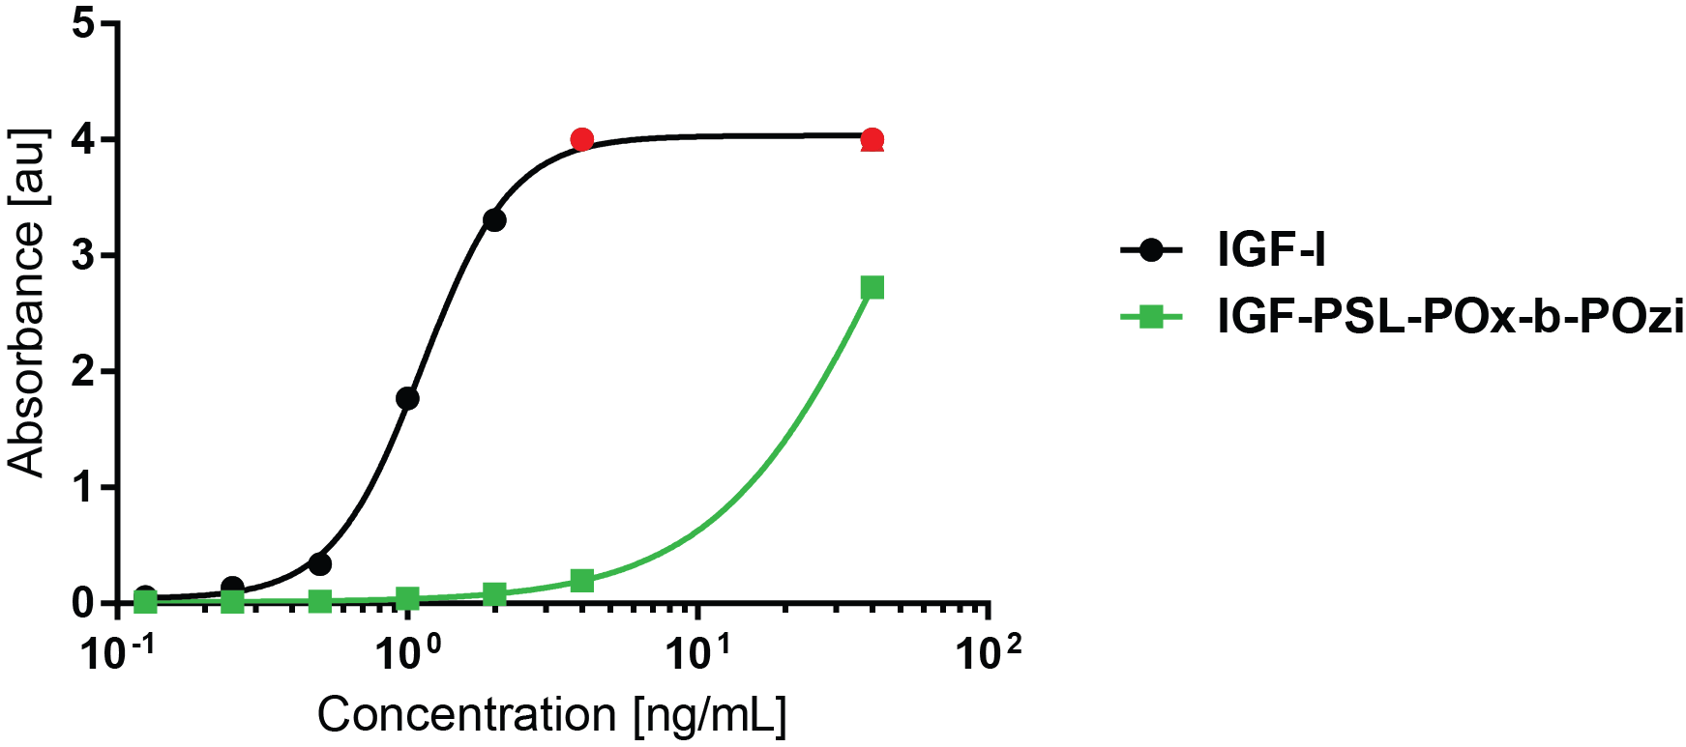

Figure S10: IGF-I ELISA standard curve for Increlex® (IGF-I) and IGF-PSL-POx-b-POzi. Red dots were not measurable and set to maximal possible measurable value.

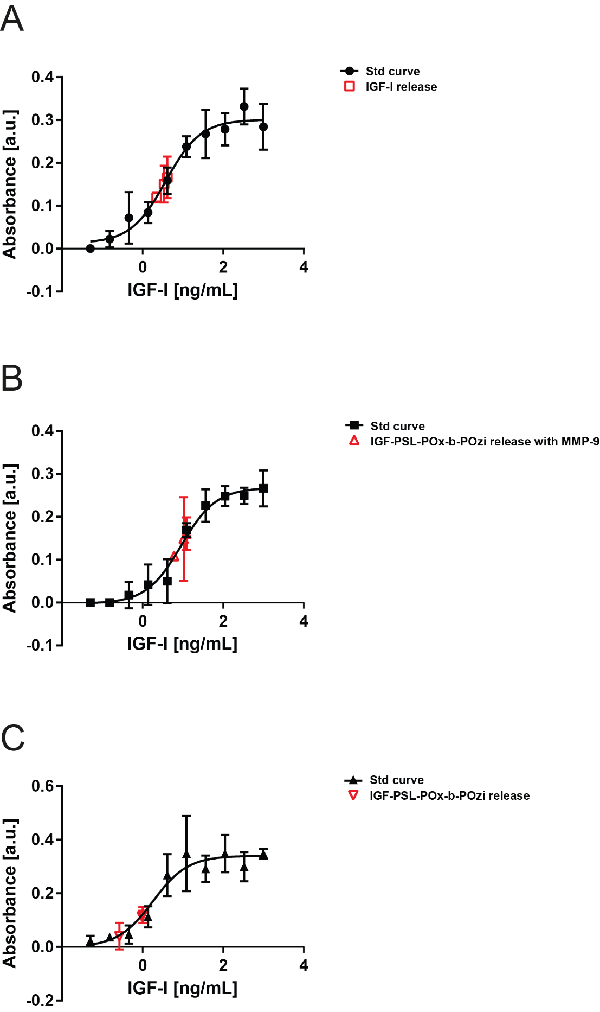

Figure S11: WST-1 standard curve of IGF-I (n=3).

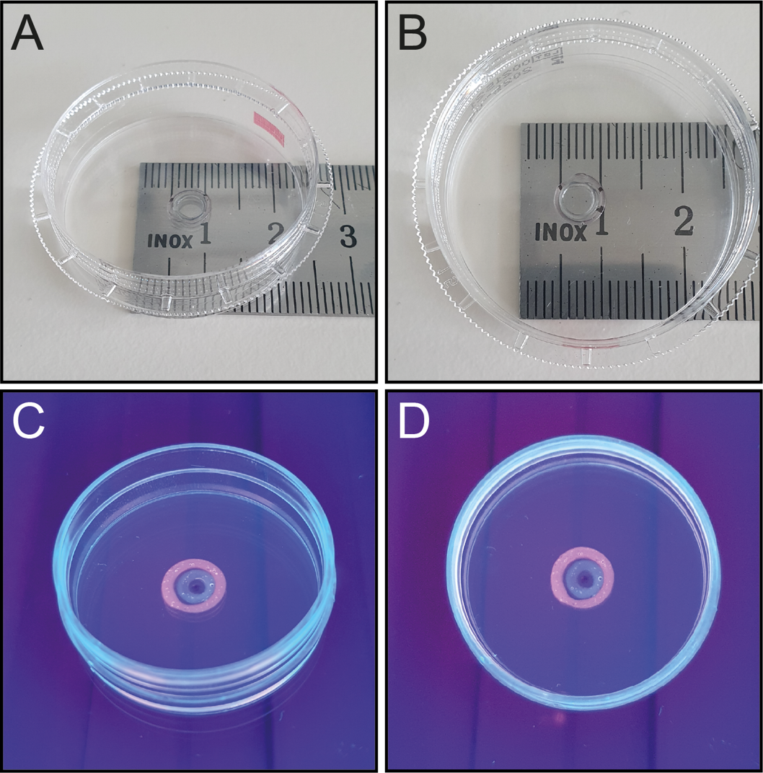

Figure S12: (A-B) 3D printed construct with IGF-PSL-POx-b-POzi. (C-D) 3D printed construct with IGF-PSL-POx-b-POzi (green) visualized via NHS-labelling with NHS Alexa FluorTM 488 and Texas Red C2 MaleimideTM (red; P-Fu modified via Diels-Alder chemistry)

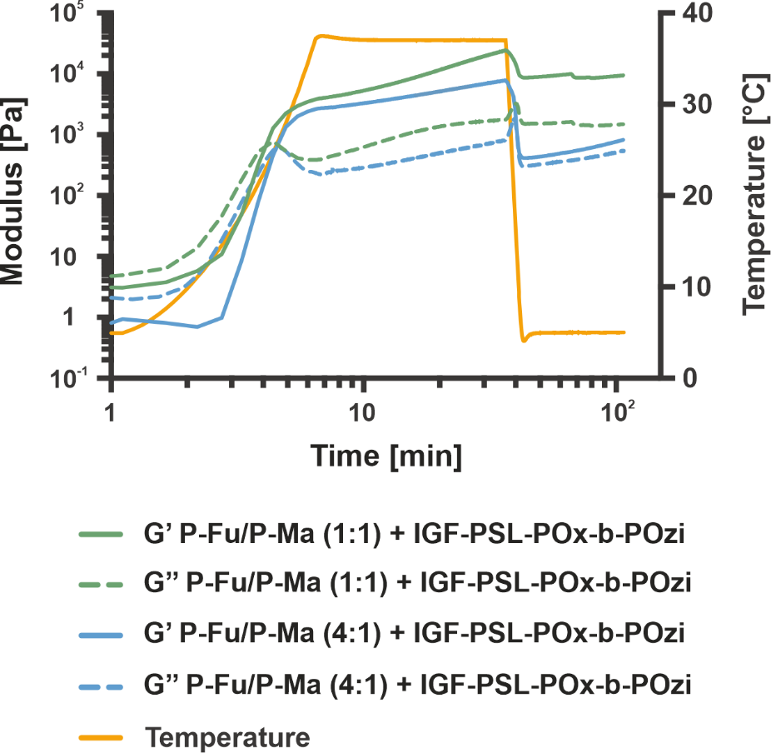

Figure S13: Chemical cross-linking of POx-b-POzi hydrogels with IGF-PSL-POx-b-POzi in the temperature range of 5 to 37 °C at 25 wt.% aqueous solutions.

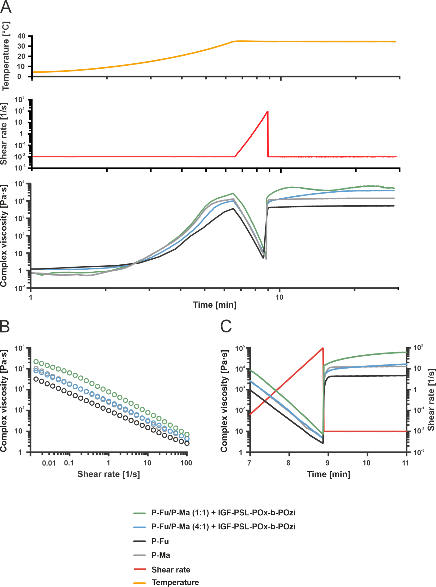

Figure S14: Rheological measurements of POx-b-POzi hydrogels simulating a printing process with and without the addition of IGF-PSL-POx-b-POzi. (A) Overview over the whole process. (B) Shear thinning behaviour of the the POx-b-POzi hydrogels. (C) Recovery of POx-b-POzi hydrogels.

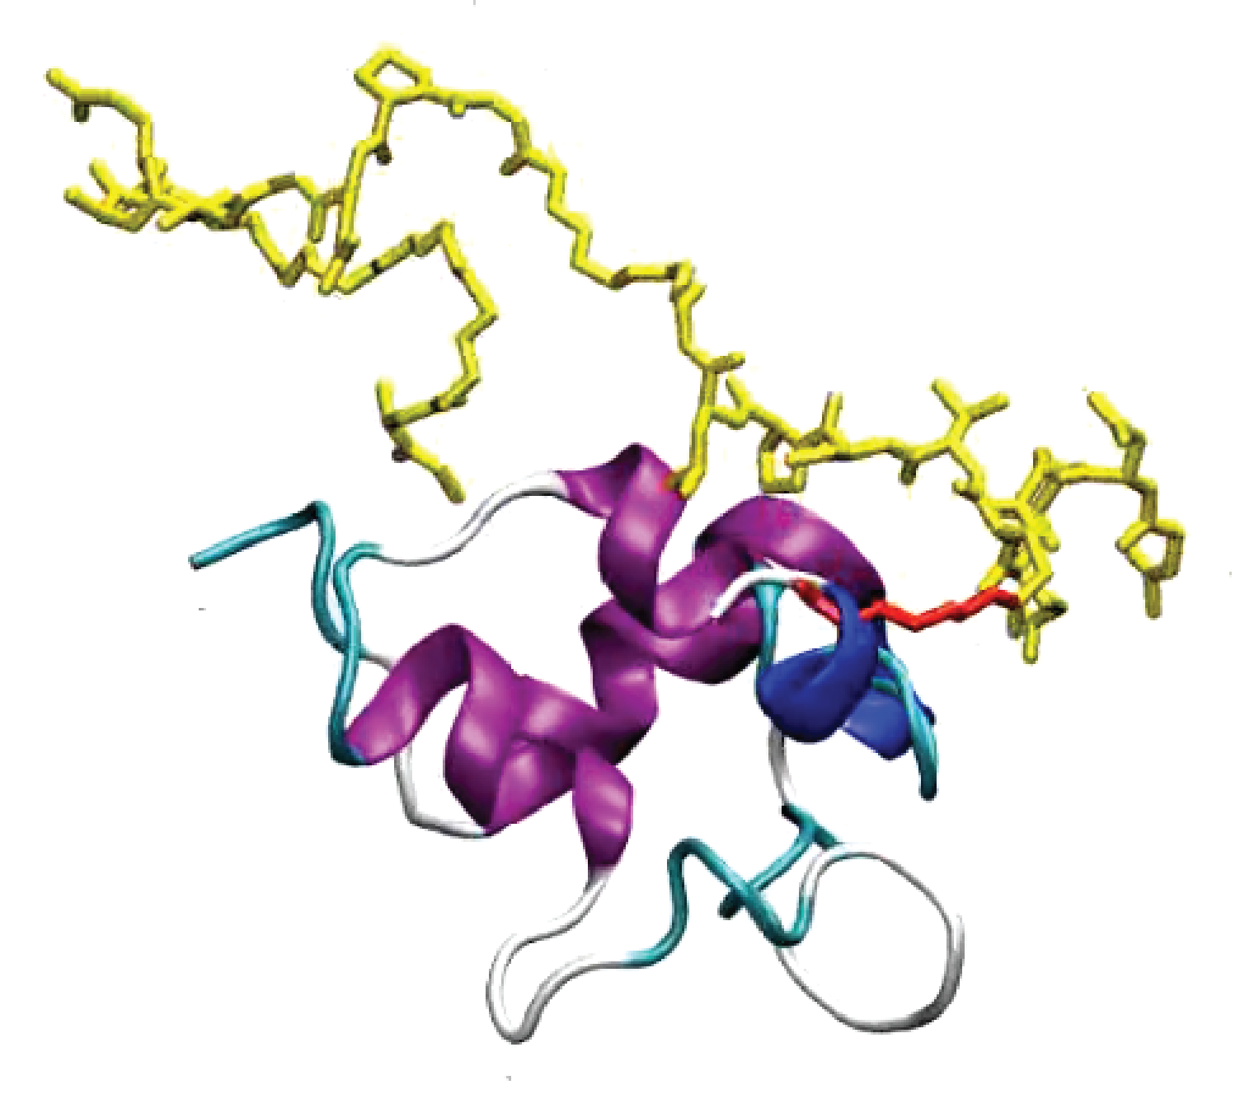
Video S1: Dynamics of PSL-bound IGF-I. IGF-I is shown in ribbon presentation (colored according to the initial secondary structure), the PSL is shown in yellow stick presentation, and the isopeptide bond in red. The data corresponds to 1 µs simulation time from simulation run 1. Motions of the protein are smoothed over 5 time frames to improve visual impression.

