Merging bioresponsive release of insulin-like growth factor I
with 3D printable thermogelling hydrogels

Matthias Beudert¹, Lukas Hahn^{1,2}, Anselm H.C. Horn^{3,4}, Niklas Hauptstein¹, Heinrich Sticht^{3,4}, Lorenz Meinel^{1,5}, Robert Luxenhofer^{2,6}, Marcus Gutmann¹*, Tessa Lühmann¹*

¹ University of Würzburg, Institute for Pharmacy and Food Chemistry, 97074 Würzburg, Germany
² Functional Polymer Materials, Chair for Advanced Materials Synthesis, Institute for Functional Materials and Biofabrication, Department of Chemistry and Pharmacy, Julius-Maximilians-University Würzburg, Röntgenring 11, 97070 Würzburg, Germany
³ Bioinformatics, Institute of Biochemistry, Friedrich-Alexander-Universität Erlangen-Nürnberg, Fahrstraße 17, 91054 Erlangen, Germany
⁴ Erlangen National High Performance Computing Center (NHR@FAU), Friedrich-Alexander-Universität Erlangen-Nürnberg, Martensstraße 1, 91058 Erlangen, Germany
⁵ Helmholtz Institute for RNA-based Infection Research, Josef-Schneider-Straße 2, DE-97080 Würzburg, Germany.
⁶ Soft Matter Chemistry, Department of Chemistry and Helsinki Institute of Sustainability Science, Faculty of Science, University of Helsinki, P.O. Box 55, 00014 Helsinki, Finland

Key Words: matrix metalloproteinase; IGF-I; POx; poly(2-methyl-2-oxazoline)-b-poly(2-propyl-2-oxazine); biofabrication; 3D printing; transglutaminase

*Corresponding authors:
Prof. Dr. Tessa Lühmann, Institute for Pharmacy and Food Chemistry, University of Würzburg, Am Hubland, DE-97074 Würzburg, Germany, E-Mail: tessa.luehmann@uni-wuerzburg.de
Dr. Marcus Gutmann, Institute for Pharmacy and Food Chemistry, University of Würzburg, Am Hubland, DE-97074 Würzburg, Germany, E-Mail: marcus.gutmann@uni-wuerzburg.de
Abstract
3D printing of biomaterials enables spatial control of drug incorporation during automated manufacturing. This study links bioresponsive release of the anabolic biologic, insulin-like growth factor-I (IGF-I) in response to matrix metalloproteinases (MMP) to 3D printing using the block copolymer of poly(2-methyl-2-oxazoline) and thermoresponsive poly(2-n-propyl-2-oxazine) (POx-b-POzi). For that, a chemo-enzymatic synthesis was deployed, ligating IGF-I enzymatically to a protease sensitive linker (PSL), which was conjugated to a POx-b-POzi copolymer. The product was blended with the plain thermogelling POx-b-POzi hydrogel. MMP exposure of the resulting hydrogel triggered bioactive IGF-I release. The bioresponsive IGF-I containing POx-b-POzi hydrogel system was further detailed for shape control and localized incorporation of IGF-I via extrusion 3D printing for future applications in biomedicine and biofabrication.

Introduction
3D printing holds the potential of spatial arrangement of biomaterials, living cells, and drug molecules, enabled by automated manufacturing procedures.¹ Thereby, the modulation of the spatial distribution or separation of drug molecules in line with their release kinetics may yield into individualized constructs for biomedical application.² One key component for 3D bioprinting is the biomaterial based bioink. Biomaterial inks are composed of hydrogels/polymers that may contain further biologically active additives while bioinks are defined by the incorporation of cells to the formulation.³ Often, these inks are handled as sol before and are crosslinked immediately during the printing process.³⁻⁴ This can be achieved via chemical cross-linking of complementary functional groups, ionic crosslinking or after being exposed to an external impulse like UV-light for photopolymerization, among others.⁵⁻⁸ Alternatively, highly shear-thinning hydrogels can liquify during the printing process and solidify immediately after exiting the nozzle. As UV radiation during cross-linking may influence drug stability and biocompatibility⁸⁻⁹, responsive polymers (e.g. pH-sensitive, temperature-sensitive, ion-sensitive) have been brought lately to the spotlight.¹⁰⁻¹¹ Especially thermogelling and shear-thinning hydrogels have gained attention due to their thermoresponsive properties as bioink material.¹²⁻¹³ This type of hydrogel may be a sol at a certain temperature and gels at another. Typically, formation of a hydrogel occurs by physical interaction. Besides biological thermogelling polymers including methylcellulose¹⁴ or agarose¹⁵, synthetic polymers show thermoresponsive behavior with several advantages over natural polymers such as high versatility in chemical functionalization, rapid gelation and comparably easy modification of gelling behavior.¹⁶⁻¹⁷ Among synthetic thermogels, block copolymers and in particular poloxamers (in particular Pluronic® F127) are established systems.¹⁸⁻²¹ An alternative class of thermoresponsive polymers that has been intensively studied is based on poly(2-substituted-2-oxazoline)s (POx) and more recently also poly(2-substituted-5,6-dihydro-4H-1,3-oxazine)s (poly(2-oxazine)s (POzi).²²⁻²⁵ These two closely related polymer families have previously been used as non-fouling materials and for drug formulations with good cytocompatibility.²⁵⁻³¹ Some members of this family have shown excellent biocompatibility in several species, including one particular POx-drug conjugate that already has advanced into clinical trials.³²⁻³³ Furthermore, amphiphilic poly(2-oxazolines) are able to improve cellular and neuronal uptake of conjugated proteins.³⁴⁻³⁵ Besides several inverse thermogelling hydrogels³⁶, an AB-type diblock copolymer consisting of a hydrophilic poly(2-methyl-2-oxazoline) A block and a thermoresponsive poly(2-n-propyl-2-oxazine) (nPrOzi) B block showed physical thermogelling at room temperature. Moreover, this POx-b-POzi based hydrogel displayed rapid and complete recovery after application of shear stress rendering it a promising material for biofabrication.³⁷ We recently showed that introduction of different chemical functionalities (furan-, maleimide-moieties) to POx-b-POzi allowed for defined chemical functionalization without affecting the rheological properties before and during the printing process, enabling chemical crosslinking via Diels-Alder chemistry thereafter.³⁸
The addition of recombinant therapeutic proteins and peptides into biomaterial- and bioinks becomes more and more important for therapeutic use.³⁹ Up to date, model proteins and growth factors have been physically loaded into printable hydrogel systems with the aim to direct cellular function with sustained drug release profiles.⁴⁰⁻⁴¹ In order to link drug release to disease patterns, collagenases such as matrix metalloproteinases (MMPs) are frequently used.⁴²⁻⁴³ We recently showed that a bioconjugate of IGF-I and polyethylene glycol (PEG) linked by a protease sensitive linker (PSL) was effective in releasing IGF-I in response to MMPs.⁴⁴⁻⁴⁶
IGF-I (7.5 kDa)⁴⁷ is therapeutically used for the treatment of dwarfism.⁴⁸⁻⁵⁰ In tissue injury, locally synthesized IGF-I critically impacts trophic tissue repair.⁵¹⁻⁵² IGF-I plays a critical role in a number of biological processes, including proliferation and protection against apoptosis, which positively influences tissue growth, repair and regeneration of many cell types.⁵³⁻⁵⁵ Despite its outstanding effects, adequate therapies with IGF-I remain difficult due to its short half-life and potential side effects after systemic administration (mainly hypoglycaemia)^{48-50, 56-57}, which has sparked interest in local depot/administration and controlled release systems to overcome these limitations.⁵⁸⁻⁶⁵
In this study, we synthesised a novel copolymer POx-b-POzi-DBCO for modification of IGF-I using enzymatic and bioorthogonal bioconjugation strategies. The IGF-I bioconjugate was designed for physical incorporation into the thermogelling POx-b-POzi hydrogel system without changing its physiochemical properties during bioprinting and for bioresponsive release of IGF-I in response to MMP. By combination of the bioconjugate with the thermogelling POx-b-POzi hydrogel system, a 3D-printable construct with spatial control of IGF-I function was achieved, which preserved IGF-I activity as prerequisite for future biomedical applications.

Materials and Methods
Materials
All substances and reagents for the monomer and polymer synthesis were purchased from Sigma-Aldrich (Steinheim, Germany) and were used as received unless otherwise stated. Deuterated solvents for NMR analysis were obtained from Deutero GmbH (Kastellaun, Germany). For polymerization, methyl trifluoromethylsulfonate (MeOTf), 2-methyl-2-oxazoline (MeOx) and 2-n-propyl-2-oxazine (nPrOzi) were refluxed over CaH₂ for several hours and distilled prior to usage. The solvent benzonitrile (PhCN) was dried over phosphorus pentoxide.
The monomers MeOx and nPrOzi were synthesized by the Witte and Seeliger⁶⁶ method like described several times.^{36, 67}
Recombinant human insulin-like growth factor I (IGF-I; Mecasermin; Increlex®) was purchased from Ipsen Group (Paris, France). Fibrogammin® was purchased from CSL Behring (Marburg, Germany). Protected L-amino acids used for peptide synthesis as well as acetonitrile (HPLC grade), trifluoroacetic acid (HPLC grade) were purchased from VWR (Ismaning, Germany). Fmoc-PEG(3)-COOH, Fmoc-PEG(6)-COOH, Fmoc-L-Azidohomoalanine as well as Fmoc-Rink-Amide Resin were obtained from Iris Biotech GmbH (Marktredwitz, Germany). Human neutrophil matrix metalloproteinase 9 (MMP-9) was purchased from Merck KGaA (Darmstadt, Germany). Quantikine® ELISA Human IGFI/IGF-1 was from R&D Systems (Abingdon, England) Tissue culture polystyrene (TCPS) cell culture flasks (75 cm²) were from Nunc (Thermo Fisher Scientific, Schwerte, Germany) and 96 well plates from Greiner Bio One (Frickenhausen, Germany). WST-1 was purchased from Roche (Basel, Switzerland). Fetal bovine serum (FBS) was from Gibco (Darmstadt, Germany). Penicillin G and streptomycin solution was purchased from Biochrom AG (Berlin, Germany). Dulbecco Modified Eagle Medium was from Sigma-Aldrich (Steinheim, Germany). All other chemicals used were at least of pharmaceutical grade. Phospho-p44/42 MAPK (Erk1/2) (Thr202/Tyr204) Antibody #9101, p44/42 MAPK (Erk1/2) Antibody #9102, Phospho-Akt (Ser473) (D9E) XP® Rabbit mAb #4060, Akt (pan) (C67E7) Rabbit mAb #4691 and Anti-rabbit IgG, HRP-linked Antibody #7074 were from Cell Signalling (Hitchin, UK).

Polymer synthesis
The AB diblock copolymer Me-(poly-nPrOzi)₅₀-b-(poly-MeOx)₅₀-DBCO (POx-b-POzi-DBCO) was synthesized using a general procedure based on previous reports (Figure S2 A).³⁷ In brief, under dry and inert conditions, 11 mg (0.07 mmol, 1 eq.) of MeOTf and 440 mg (3.46 mmol, 49 eq.) of nPrOzi were added to 1.5 mL of PhCN and stirred for 4 h at 130 °C. Full monomer conversion was monitored by ¹H NMR spectroscopy. The second block 300 mg MeOx (3.52 mmol, 50 eq.) was added, and the reaction mixture was stirred for 2 h at 110 °C. After completion of the second block, termination was carried out overnight using 93 mg of 11,12-Didehydro-ε-oxodibenz[b,f]azocine-5(6H)-hexanoic acid (DBCO-acid) (0.28 mmol, 4 eq.) and 36 mg of dried diisopropylethylamine (0.28 mmol, 4 eq.) at 60 °C. The reaction mixture was poured into ice-cold diethyl ether. The precipitate was dissolved in deionized water, dialyzed overnight using a regenerated cellulose membrane with a MWCO of 1 kDa, and freeze dried (yield: 51.4 %, 400 mg, 0.036 mmol). The polymer structure was confirmed using ¹H NMR end group analysis (Figure S2 C, D). The number average molar mass M_{n} and the dispersity Ð were determined via GPC analysis (Figure S2 B). A reasonably narrow molar mass size distribution and an increase of the number average molar mass during the polymerization reaction (M_{n} (1st block): 2.3 kg/mol, Ð (1st block): 1.25; M_{n} (2nd block): 3.8 kg/mol, Ð (2nd block): 1.30; M_{n} (purified polymer): 4.6 kg/mol, Ð (purified polymer): 1.36), indicative of the living polymerization, was confirmed. Please note, absolute values for M_{n} were not accessible via GPC due to the used calibration.
Nuclear magnetic resonance (NMR)
NMR was performed on a Bruker Fourier 300 (¹H: 300.12 MHz) spectrometer at 298 K from Bruker BioSpin (Rheinstetten, Germany) and calibrated using the solvent signals.
Gel permeation chromatography (GPC)
GPC experiments were performed on a Polymer Standard Service PSS (Mainz, Germany) system with following specifications: pump mod. 1260 infinity, MDS RI-detector mod. 1260 infinity (Agilent Technologies, Santa Clara, California, USA), precolumn: 50 x 8 mm PSS PFG linear M; 2 columns: 300 x 8 mm PSS PFG linear M (particle size 7 µm; pore size 0.1 – 1.000 kg/mol) with hexafluoroisopropanol (HFIP, containing 3 g/L potassium trifluoroacetate (KTFA)) as eluent calibrated against PEG standards with molar masses from 0.1 kg/mol to 1000 kg/mol. The columns were held at 40 °C and the flow rate was set to 0.7 mL/min. Prior to each measurement, samples were dissolved in eluent and filtered through 0.2 µm PTFE filters (Rotilabo, Karlsruhe, Germany) to remove particles, if any.
Peptide synthesis and purification of the protease-sensitive linker (PSL)
The protease-sensitive linker (PSL) with the sequence Ac-GNQEQVSPL-PEG(3)-GPQGIAGQ-PEG(6)-A(N₃) was synthesized by solid-phase fmoc-peptide synthesis using a microwave peptide synthesizer (Initiator+, Biotage, USA). Shortly, fmoc-rink-amid resin was loaded into a 15 mL reaction vessel with a glass frit in the bottom. Deprotection was done using 10 % piperidine in DMF (v/v) at 75 °C for 3 min. Subsequently, a 5-fold molar excess of the amino acid compared to the functional group was dissolved in DMF and mixed with 0.5 M 1-hydroxybenzotriazole (HOBt) (v/v) as well as diisopropylethylamine (DIPEA) and N,N’-diisopropylcarbodiimid (DIC). Coupling was performed for 3 h at 25 °C. After cleavage from the resin using 92,5 % trifluoroacetic acid (TFA), 2,5 % H₂O, 2,5% 3,6-dioxa-1,8-octanedithiol (DODT) and 2,5 % triisopropylsilane (TIPS), the peptide was purified by reversed-phase chromatography using an FPLC system (GE Healthcare Äkta Explorer, Life sciences, Freiburg, Germany) with a Luna C18 100A column (21.2 mm × 250 mm, Phenomenex Inc., Torrance, CA). Successful peptide synthesis was analyzed using high performance liquid chromatography (HPLC) and liquid chromatography-mass spectrometry (LC-MS).
Liquid chromatography-mass spectrometry (LC-MS)
Successful synthesis of PSL was determined using a LC-MS system (Shimadzu, Duisburg, Germany) equipped with a DGU-20A3R degassing unit, an LC-20AB liquid chromatograph, a SPD-20A UV/Vis detector. UV-spectra were monitored at 214 nm and mass spectra were recorded with an LCMS-2020 device (Shimadzu, Duisburg, Germany).⁶⁸ A Synergi 4 µm fusion-RP column (140 x 4.6 mm) (Phenomenex Inc., Torrance, CA) was utilized as stationary phase with a gradient of Eluant A (water, 0.1 % formic acid (v/v)) and Eluent B (methanol, 0.1 % formic acid (v/v)) as mobile phase. Gradient: 5 to 90 % of eluent B in 8 min followed by 5 min of 90 % Eluent B; 90 to 5 % eluent B in 5 min with subsequent equilibration of the column with 5 % of eluent B (4 min). Peptides were detected in a range from 500-2000 (m/z). Electrospray ionization (ESI) spectra were measured with a microTOF-focus at a capillary temperature of 210 °C and 3.5 kV voltage with the carrier gas N₂.
Matrix-assisted laser desorption/ionization (MALDI)
A solution of 20 µL (1 mg/ mL) of the sample protein was desalted using Zip Tip® C 18 resin (Merck Millipore, Billerica, USA) following manufacturer instructions. One µl of the desalted protein was emended in a matrix, consisting of 3,5-Dimethoxy-4-hydroxycinnamic acid in TA-solvent (30:70 (v/v) acetonitrile (ACN)/0.1 % trifluoroacetic acid (TFA) in water). MALDI mass spectra were acquired in the linear positive mode with a 337 nm nitrogen laser using an Autoflex II LFR instrument (Bruker Daltonics Inc., Billerica, USA). Protein Standard I (Bruker Daltonics Inc., Billerica, USA) was used for calibration. Theoretical masses of proteins were calculated (https://web.expasy.org/peptide_mass/).
Coupling of PSL-peptide with IGF-I
Factor XIIIa (FXIIIa, 250 U/mL, Fibrogammin®, CSL Behring) was activated according to the manufacturer’s protocol and stored at -80 °C until further use.
Recombinant human IGF-I (Increlex®, Ipsen Pharma GmbH) was purified by cation-exchange chromatography (CIEX) using an FPLC system (GE Healthcare Äkta Explorer, Life sciences, Freiburg, Germany) with a HiTrap SP-HP column (Cytiva, Freiburg, Germany). After buffer exchange (10 mM Tris/HCL, 150 mM NaCl, 2.5 mM CaCl₂, pH 7.6) IGF-I was incubated with 5-fold molar excess of PSL and 10 U/mL FXIIIa at 37 °C for 20 min. The reaction was monitored over the course of time using HPLC with a Zorbax® 300SB-CN (4.6 × 150 mm) column. Samples were taken at different time points and the reaction was stopped by the addition of EDTA (10 mM). The protein-peptide conjugate was purified using CIEX using an FPLC system (GE Healthcare Äkta Explorer, Life sciences, Freiburg, Germany) with a HiTrap SP-HP column (Cytiva, Freiburg, Germany) and the reaction products were analyzed using SDS-PAGE.
Site-specific conjugation with POx-b-POzi -DBCO
Purified IGF-PSL construct was dialyzed against PBS, mixed with 20-fold molar excess of POx-b-POzi-DBCO at pH 7.4 and incubated for 72 h at 4 °C while stirring gently. IGF-PSL-POx-b-POzi was purified using purified by CIEX using an FPLC system (GE Healthcare Äkta Explorer, Life sciences, Freiburg, Germany) with a HiTrap SP-HP column (Cytiva, Freiburg, Germany). The polymer conjugate was eluted with 50 mM sodium acetate, 1 M NaCl buffer at pH 4.3. Successful coupling was verified by SDS-PAGE as well as western blot. The concentration of the purified construct was determined by BCA protein assay and was stored at -20 °C until further use.
Cleavage of IGF-PSL-POx-b-POzi by MMP-9
Pro-MMP-9 was activated with 4-aminophenylmercuric acetate (APMA) according to manufacturer’s instructions. IGF-PSL-POx-b-POzi was dialyzed against MMP-buffer (50 mM Tris, 150 mM NaCl, 1 µM ZnCl₂, 10 mM CaCl₂, 0.05 % Brij 35, pH 6.8) and 3 µg of the conjugate were incubated with 8 nM of MMP-9 at 37 °C and 450 rpm. After different time points, samples were taken, and protease activity was stopped by the addition of 50 mM EDTA and heating at 95 °C for 10 min. The cleavage of IGF-PSL-POx-b-POzi over time was monitored using HPLC with a Zorbax® 300SB-CN (4.6 × 150 mm) column. Samples were analyzed after 0, 2, 6, and 24 h of exposure to MMP-9, respectively.
SDS-PAGE
Purified proteins and conjugates were analyzed using Tris-glycine SDS-PAGE as described before.⁵⁸ Gels were stained with Coomassie Brilliant Blue G250 Merck KGaA (Darmstadt, Germany) and documented using FluorChem FC2 imaging system (Protein Simple, Santa Clara, USA).
pAKT/AKT and pERK/ERK signaling
Extracellular signalling of IGF-I variants in respect to human IGF-I was conducted by pAKT/AKT and pERK/ERK assay. C2C12 myoblasts were seeded in a 96-well plate (1x10³ cells/mL, 125 µL per well) in growth medium overnight at 37 °C under 5 % CO₂. The medium was changed to assay medium (DMEM high-glucose 0.5 % FCS, 100 U/mL penicillin G and 100 µg/mL streptomycine) and cells were grown for 24 h. Cells were stimulated with a dilution series of each IGF-I variant as well as IGF-I ranging from 0.02 to 200 nM and incubated for 30 minutes at 37 °C. After stimulation, the cells were placed on ice, washed with ice cold PBS and proteins were extracted using mammalian extraction buffer (M-PER™ Mammalian Protein Extraction Reagent, Thermo Scientific). After extraction, proteins were immediately shock frozen using liquid nitrogen. The concentration of each condition was determined by BCA assay following manufacturer instructions. 1 µg total protein of each condition was loaded on a 12 % SDS-Page gel and processed using standard SDS-PAGE and Western blotting procedures. Prior to phosphorylated AKT/ERK analysis, Ponceau red staining was performed. For detection of phosphorylated AKT, a Phospho-Akt (Ser473) (D9E) XP® Rabbit mAb (1:1000) in Tris buffered saline (TBS), containing 0.1 % (w/w) Tween-20 (TBST) and for phosphorylated ERK, a Phospho-p44/42 MAPK (Erk1/2) (Thr202/Tyr204) antibody was used overnight at 4 °C, respectively. After incubation with the first antibody, the blot was washed and incubated with an Anti-rabbit IgG, HRP-linked Antibody (1:2000 in TBST). Signals were detected using SuperSignal™ West Pico PLUS Chemiluminescent Substrate and were subsequently monitored by a FluorChem FC 2 imaging system (Protein Simple, Santa Clara, USA). After detection of the phosphorylated AKT/ERK, the blot was stripped with 2-Mercaptoethanol-Buffer (50 mM Tris-HCl, 2 % (w/w) SDS and 0.8 % 2-mercaptoethanol-buffer, pH 6.8) for 45 minutes at 56 °C and was washed under rinsing water for 1 h. For the detection of AKT, an Akt (pan) (C67E7) Rabbit mAb (1:1000 in TBST) and for the detection of ERK a p44/42 MAPK (Erk1/2) antibody as well as Anti-rabbit IgG (1:2000 in TBST), HRP-linked antibody was used with identical steps, respectively.
Cell Culture
Immortalized mouse myoblast C2C12 cells (ATCC CRL-1772) were cultured in growth medium (DMEM high-glucose 10 % FCS, 100 U/mL penicillin G and 100 µg/mL streptomycin) on 75 cm² culture flasks at 37 °C and 5 % CO₂.
WST-1 proliferation assay
Bioactivity of IGF-I variants compared to human IGF-I was conducted by formazan assay. In brief, C2C12 myoblasts were seeded in a 96-well plate (2x10³ cells/mL, 125 µL per well) in growth medium overnight at 37 °C under 5 % CO₂. The medium was changed to assay medium (DMEM high-glucose 0.5 % FCS, 100 U/mL penicillin G and 100 µg/mL streptomycin) and cells were grown for 24 h. Dilution series of each IGF-I variant as well as IGF-I ranging from 0.01 nmol to 200 nmol were prepared in assay medium and added (1:1 (v/v)) to the cells. Cells were stimulated for 24 h at 37 °C and 5 % CO₂. After stimulation, 10 µL WST-1 reagent were added to each well and cells were incubated for 4 h at 37 °C according to manufacturer instructions. Every 30 minutes, cells were analyzed and the absorbance of the soluble formazan product at 450 nm as well as background noise at 630 nm were determined using an Infinite 200Pro (Tecan, Männerdorf, Switzerland).
Bioresponsive release from POx hydrogels
25 wt.% solutions of P(MeOx₉₀-co-Fu₁₀)-b-PnPrOzi₁₀₀ (P-Fu) and P(MeOx₉₀-co-Ma₁₀)-b-PnPrOzi₁₀₀ (P-Ma) were prepared in MMP-buffer (50 mM Tris, 150 mM NaCl, 1 µM ZnCl₂, 10 mM CaCl₂, pH 7.4) at 4 °C. P-Fu and P-Ma were mixed in ratio of 1:4 (P-Fu:P-Ma) and IGF or IGF-PSL-POx-b-POzi (final concentration 10 µg/ml) were added to the mixture. 20 µL gels were casted in 96 well plate. After 45 min of incubation at 37 °C the hydrogels were overlayed with 180 µL MMP-buffer. MMP-9 was added to a final concentration of 8 nm. Gels were incubated at 37 °C and 100 rpm. Samples were taken after 0, 2, 4 and 6 h and instantly frozen in liquid nitrogen. The release of IGF-I as well as its bioactivity were monitored using WST-1 proliferation assay.
Enzyme-linked Immunosorbent Assay (ELISA)
IGF-I (Increlex®) and IGF-PSL-POx-b-POzi were analyzed using standard sandwich ELISA, following manufacturer’s instructions. In brief, IGF-I and IGF-PSL-POx-b-POzi were diluted in Calibrator RD5-18 ranging from 40 ng/mL to 0.125 ng/mL, respectively. The microplate was washed initially as well as after each following step with 300 µl Assay Diluent RD1-99 and incubated for 3 h at 4 °C. 200 µL Human IGF-I conjugate was added to each well for 1 h at room temperature. For detection, 200 µL Substrate AB solution was added to each well and incubated for 30 min. The reaction was stopped by adding 50 µL Stop Solution and absorption was measured at 450 nm and 630 nm with a microplate reader (Infinite® F200, Tecan, Meannedorf, Switzerland), respectively.
NHS-labelling
IGF-PSL-POx-b-POzi was incubated with a 20-fold molar excess of Atto 488-NHS-ester (Sigma-Aldrich, Steinheim, Germany) in bicarbonate buffer (100 mM) for at least 1 h. Unattached Atto 488-NHS-ester was removed from the solution via spin column (VivaspinTM, Satorius, Göttingen, Germany).
Rheology
Experiments were performed on an Anton Paar (Ostfildern, Germany) Physica MCR302, equipped with peltier elements (P-PTD200/Air & H-PTD200) and a solvent trap as described previously.⁶⁹ Briefly, the pre-cooled samples (final polymer concentration: 25 wt.%; IGF-PSL-POx-b-POzi: 25 µg/mL) were placed on the cooled rheometer (5 °C). First, to simulate the printing workflow, G’ and G’’ were recorded for 10 min at 5 °C and a fixed amplitude of 0.5 % and angular frequency of 10 rad/s. Subsequently, a temperature sweep from 5 to 37 °C was conducted. The crosslinking kinetics were monitored for 2 h at 37 °C (angular frequency: 10 rad/s, amplitude: 0.5 %). To highlight the covalent crosslinks further experiments were performed. After crosslinking for several minutes at 37 °C the crosslinked samples were cooled to 5 °C recording G´ and G´´. In the end, experiments were performed to evaluate all aspects of the printing process:
- Sample equilibration (5 °C, shear rate: 0.01 1/sec, 1 minute)
- Temperature sweep (5 °C - 37 °C, shear rate: 0.01 1/sec, 0.1 °C/s, approx. 5 minutes)
- Shear response (37 °C, shear rate: 0.01 - 100 1/s)
- Recovery and crosslinking (37 °C, shear rate: 0.01 1/s)
Circular dichroism (CD) spectroscopy
Samples were dialyzed against 10 mM NaOAc (pH 4.3), or 20 mM NaH₂PO₄ (pH 7.5) for 2 days at 4 °C. The identical buffers were used for blank measurements. CD spectra were recorded at the indicated temperature in a 1 mm path length cell on a spectropolarimeter and 5 scans were averaged (J715 spectropolarimeter, equipped with a Jasco peltier element, Jasco Labor- and Datentechnik GmbH, Groß-Umstadt, Germany). The following parameters were used: 100 mdeg sensitivity, 0.1 nm step resolution, 50 nm min⁻¹ scan speed from 260 - 190 nm, 2 s time constant. Protein solutions had a concentration of 0.16 - 0.2 mg/mL. Heated samples were heated at a rate of 2 °C per min. Raw data were processed with Graphpad Prism 6 (GraphPad Software, La Jolla California USA, www.graphpad.com) and smoothing was performed using 10 neighbouring points on each side.
Direct ink-writing
For the printing of hydrogel scaffolds an extrusion-based bench-top 3D bioprinter (Bio X, Cellink, Sweden) was used. 25 wt.% aqueous solutions of both furan- and maleimide-modified polymer were prepared and mixed at 4 °C and subsequently printed at room temperature. Both polymers were mixed in a ratio of 6:10 with respect to furan-modified polymer and transferred immediately to the nozzle. The printer was equipped with a 22 GA (Cellink, #30047) diameter precision nozzle. A pressure ranging from 120 to 180 kPa was applied and the printing speed was set to 3 mm/s. The print bed was preheated to 40 °C. For the visualization of the printed constructs, Texas RedTM C₂ Maleimide (0.1 mg/mL) (Thermofisher Scientific) or IGF-PSL-POx-b-POzi-Atto 488 were added to the precursor solutions to a final concentration around 23 wt.% of the biomaterial ink. After printing, the constructs were incubated at 37 °C and 5 % CO₂. After incubation of at least 30 min the constructs were overlayed with ddH₂O and incubated at 37 °C and 5 % CO₂.
Fluorescence microscopy
Distribution of IGF-PSL-POx-b-POzi in the 3D construct after printing was analyzed using an Axio Observer.Z1 microscope equipped with an A-Plan 10x/0.25 Ph1 objective (Zeiss), 38 HE Green Fluorescent Protein (λ_{ex}= 450-490 nm λ_{em}= 500-550 nm), 43 DsRed Reflector (λ_{ex}= 538-562 nm λ_{em}= 570-640 nm) and a mercury vapor short-arc lamp. Image processing was performed in ImageJ (http://imagej.nih.gov/ij/).
Molecular dynamics simulations
Simulations started from the solution structure of IGF-I (PDB code 2GF1⁷⁰) with the protease sensitive linker (PSL) attached via an isopeptide bond. For the parametrization of the PEG spacers within the PSL, atomic charges were derived using the R.E.D. server.⁷¹ The parm14SB force field⁷² was used for the amino acids of PSL and IGF-I, and TIP3P⁷³ for water. Four starting conformations were generated: two contained the linker peptide in extended conformation and in the other two the initial linker peptide conformation was selected from a previous short MD simulation of the isolated PSL. All systems were placed in truncated octahedral water boxes containing one Na⁺ counter ion for electrical neutralization and ~22,000 water molecules, thus ensuring that even the most extended system was solvated with at least 12 Å distance to the border of the periodic boundary box. Simulations were performed with AMBER20⁷⁴ using the GPU-accelerated version of pmemd⁷⁵⁻⁷⁶ on A100 Nvidia cards. The four independent simulations (1 µs each) were run as NPT ensemble at 310 K and 1 bar with a time step of 2 fs using SHAKE to constrain hydrogen atoms⁷⁷⁻⁷⁸, following a previously established simulation protocol⁷⁹. Structural analysis and visualization were done with the program VMD.⁸⁰
Statistics
All data were reported as mean ± standard deviation unless specified otherwise. Statistical significance was calculated by Tukey’s one-way analysis of variance (OriginLab, Northampton, USA; GraphPad Software, La Jolla, CA). P-values less than 0.05 were considered statistically significant.
Results and Discussion
The IGF-PSL-POx-b-POzi conjugate was designed to enable physical anchoring and bioresponsive release of IGF-I by MMPs from the thermogelling POx-b-POzi hydrogel system.³⁸ Here, the conjugate was obtained by transglutaminase-mediated coupling of IGF-I to a PSL using lysine (K) at position 68, following published procedures (Figure 1A, B).⁴⁶ This approach has the advantage of controlled site-specific conjugation of IGF-I compared to unspecific chemical conjugation methods such as 1-ethyl-3-(3-dimethylaminopropyl)carbodiimide chemistry, which may impair protein’s active sites, potentially affecting biological performances as well as leading to high batch to batch variations during the production process.⁸¹⁻⁸² Furthermore, K68 is part of the D domain of IGF-I which is not involved in receptor binding and therefore does not affect the IGF-I `s bioactivity (Figure 1A).⁸³⁻⁸⁵ To this end, a transglutaminase donor peptide -NQEQVSPL-, derived from alpha-2 plasmin inhibitor (α2PI)⁸⁶, was added at the N-terminus of the MMP-sensitive sequence (GPQGIAGQ; derived from type I collagen⁸⁷⁻⁸⁸) as well as an azide functionalization located at the C-terminus (Figure 1A). Using the extended termini at the C-terminus, the PSL was coupled (1) to IGF-I via the N-terminal transglutaminase donor peptide and (2) to the polymer POx-b-POzi-DBCO via the C-terminal azide function using strain-promoted azide-alkyne cycloaddition (SPAAC).
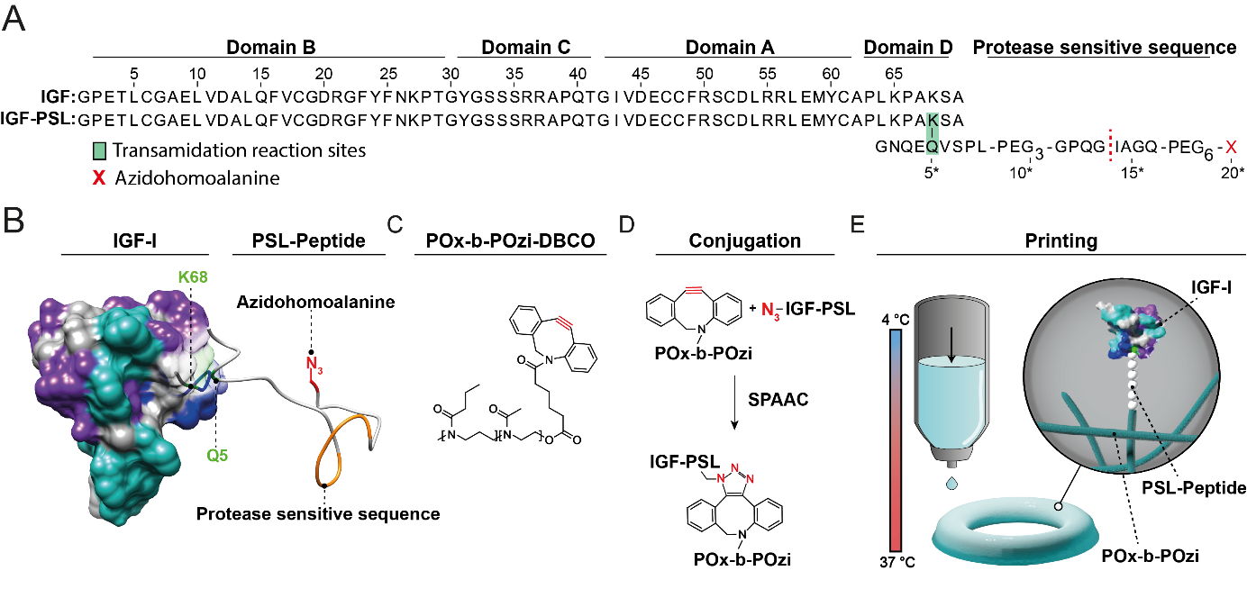
Figure 1: Bioinspired site-directed IGF-polymer conjugation. (A) Alignment of amino acid sequence of human IGF-I and IGF-PSL. The sequence alignment was created with Jalview 2.11.1.4.⁸⁹ (B) 3D structure of human IGF-1 (PDB code 2GF1⁷⁰) and PSL (depicted structure is an approximation created by using Pep-Fold3 Best-Model prediction). (C) Structure of Me-PnPrOzi₅₀-b-PMeOx-DBCO (POx-b-POzi-DBCO) (D) POxylation of IGF-PSL using SPAAC. Molecular structures were created using UCSF Chimera 1.15.⁹⁰ (E) Scheme of the printing process of IGF-PSL-POx-b-POzi.
For IGF-I bioconjugation, a POx-b-POzi-DBCO diblock copolymer comprising a hydrophilic PMeOx block and a thermoresponsive PnPrOzi block (POx-b-POzi) with a DBCO functionalization was developed. The design of the polymer was not intended to be used for half-life extension as frequently used for systemically applied therapeutic proteins^{43, 91-92} but for anchoring of IGF-I into the thermogelling POx-b-POzi hydrogel system (Figure 1B).
Prior to the synthesis of the polymer and peptide, we used molecular dynamics (MD) simulations to assess the properties of the PSL with respect to the formation of intramolecular interactions that might hamper receptor binding. Based on four independent 1-µs MD simulations, the interactions between the PSL and IGF-I were monitored (Figure 2B; S1). The dynamics of simulation run 1 is available as supplementary movie (Video S1) and representative snapshots from this simulation are shown in Figure 2A. All simulations showed that the PSL fused to the C-terminus of IGF-I is highly dynamic and only formed transient interactions. These results indicate that the IGF-PSL interaction is weak and will not critically affect receptor binding affinity.
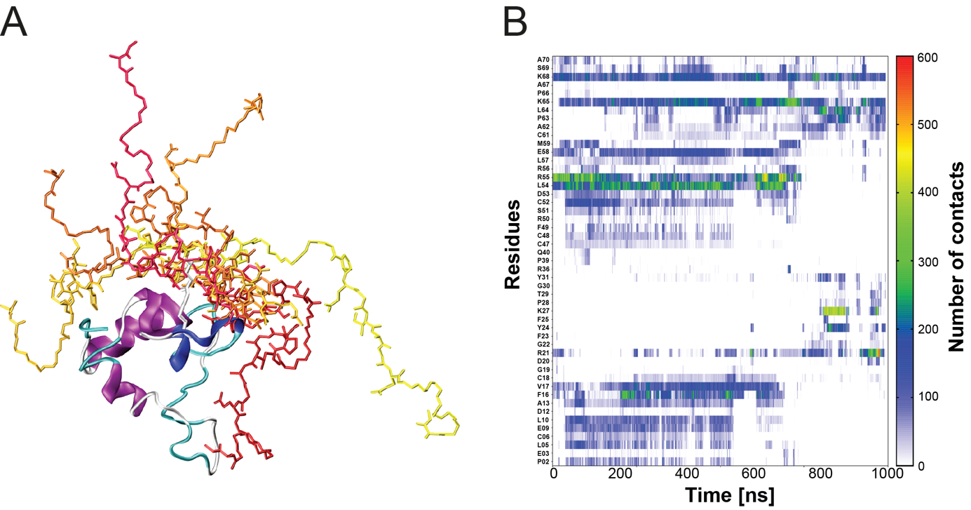
Figure 2: Molecular dynamics simulation of IGF-PSL (A) Structure of PSL-bound IGF-I. For PSL, snapshots from different time points of the molecular dynamics simulation are overlaid. IGF-I is shown in ribbon presentation (colored according to the secondary structure) and PSL is shown in stick presentation (colors from yellow to dark red correspond to progressing time points of the simulation). (B) Number of contacts between PSL and IGF-I over the simulation time (run 1). The simulation time is shown as horizontal axis and the interacting IGF-I residues on the vertical axis. The number of IGF-PSL contacts is color coded (see vertical scale bar on the right).
Afterwards, the PSL-peptide was synthesized using solid-phase fmoc-peptide synthesis and analyzed by ESI-MS and RP-HPLC (Figure S3). Assembly of the IGF-PSL construct was achieved by coupling IGF-I with PSL using the transglutaminase factor XIIIa (vide supra). The successful coupling of IGF-I and PSL was confirmed using RP-HPLC (Figure 3A), SDS-PAGE (Figure 3B), and MALDI-MS analysis (Figure S4). RP-HPLC analysis revealed that the enzymatic protein-peptide conjugation is rapid with around 60 % conversion after 20 min (Figure 3C). The final IGF-PSL was purified using cation-exchange chromatography (CIEX) with a purity > 95 %.
The thermoresponsive polymer Me-PnPrOzi₅₀-b-PMeOx-DBCO (POx-b-POzi-DBCO; Figure 1C, Figure S2 A) was synthesized by living cationic ring opening polymerization. The DBCO functionality at the omega-chain-end was introduced via termination reaction of deprotonated DBCO-acid as nucleophile after complete monomer consumption. The polymerization was monitored via ¹H NMR and GPC analysis (Figure S2 B-D) and the polymer structure was confirmed via ¹H NMR end group analysis (Figure S2 C, D). An increase in the number average molar mass during sequential polymerization was confirmed via GPC and the purified polymer exhibited a reasonably narrow molar mass size distribution (Ð = 1.36; Figure S2 B).
The conjugate IGF-PSL-POx-b-POzi was prepared by coupling the POx-b-POzi-DBCO to the C-terminal azide function of the PSL-peptide within the IGF-PSL sequence using SPAAC (Figure 1D). After 48 h of incubation, IGF-PSL-POx-b-POzi was purified using CIEX leading to a protein-polymer conjugate with a purity > 95 % (Figure 3 A, B).
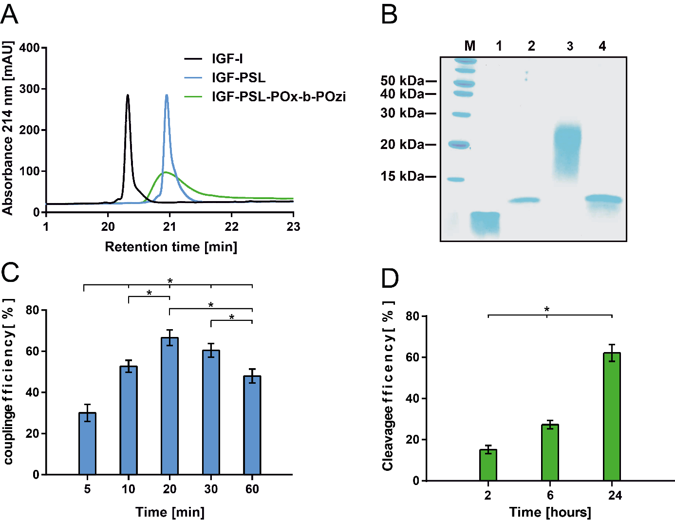
Figure 3: Characterization of IGF-PSL-POx-b-POzi conjugate. (A) RP-HPLC analysis of IGF-I, IGF-PSL and IGF-PSL-POx-b-POzi. (B) SDS-PAGE of IGF-I (1), IGF-PSL (2), IGF-PSL-POx-b-POzi (3) and cleaved IGF-PSL-POx-b-POzi (4). (C) Efficiency of the TG-catalyzed IGF-PSL coupling. (D) Cleavage efficiency of IGF PSL-POx-b-POzi with MMP-9. Mean ± SD, n ≥ 5, one-way ANOVA followed by Tukey’s Multiple Comparison Test; p ≤ 0.05 was considered statistically significant and highlighted by asterisks.
The high coupling efficiency and the homogeneous product enabled by transglutaminase and subsequent SPAAC chemistry highlight the versatility of this approach and demonstrate that bioconjugation of IGF-I to a thermoresponsive diblock copolymer originated from POx and POzi is successful. Especially in view of the increasing interest in PEG substitutes, both POx and POzi (and their combinations) represent excellent PEG alternatives due to the high flexibility in chemical synthesis and good cytocompatibility.⁹¹
The different conjugation steps starting with IGF-I (7.6 kDa) and resulting in IGF-PSL (10 kDa) (Figure S4) and IGF-PSL-POx-b-POzi (25 kDa) were followed and confirmed by SDS-PAGE. Also, reversal of the POxylation via MMP-9 mediated cleavage of IGF-PSL-POx-b-POzi was successful as shown by the appearance of the band of unconjugated IGF-I (below15 kDa) (Figure 3B). RP-HPLC analysis showed 62 % of cleaved IGF-I from IGF-PSL-POx-b-POzi over 24h (Figure 3D, S5). While the polymer conjugate showed a broader distribution in both RP-HPLC and SDS-PAGE, the cleaved IGF-I product displayed narrower signals, in line with the removal of the disperse polymer (Figure 3B).
Successful cleavage of the protein-polymer conjugate IGF-PSL-POx-b-POzi was achieved at 8 nM of activated MMP-9. This MMP concentration was chosen as it represents the range of upregulated enzyme levels of proteolytically active MMP-9 during the course of inflammation in diseased tissues such as in rheumatoid arthritis.⁹³ Our results demonstrate that the integrated MMP-sensitive sequence within the IGF-PSL-POx-b-POzi is accessible for the enzyme MMP-9 and full-length IGF-I is released from its bioconjugate as previously monitored for PEGylated IGF-I.⁴⁶
CD analysis revealed that all tested proteins and conjugates remained α-helical as described before for IGF-I⁹⁴, indicating that peptide and polymer conjugation does not affect secondary structure (Figure 4A). Moreover, enzymatic conjugation to the PSL did not alter thermal stability of IGF-I (Figure S6).
Bioactivity of the different IGF-conjugates were analyzed by WST-1 proliferation assay (Figure 4B, S7) and ERK and AKT phosphorylation, respectively (Figure 4C, S8).
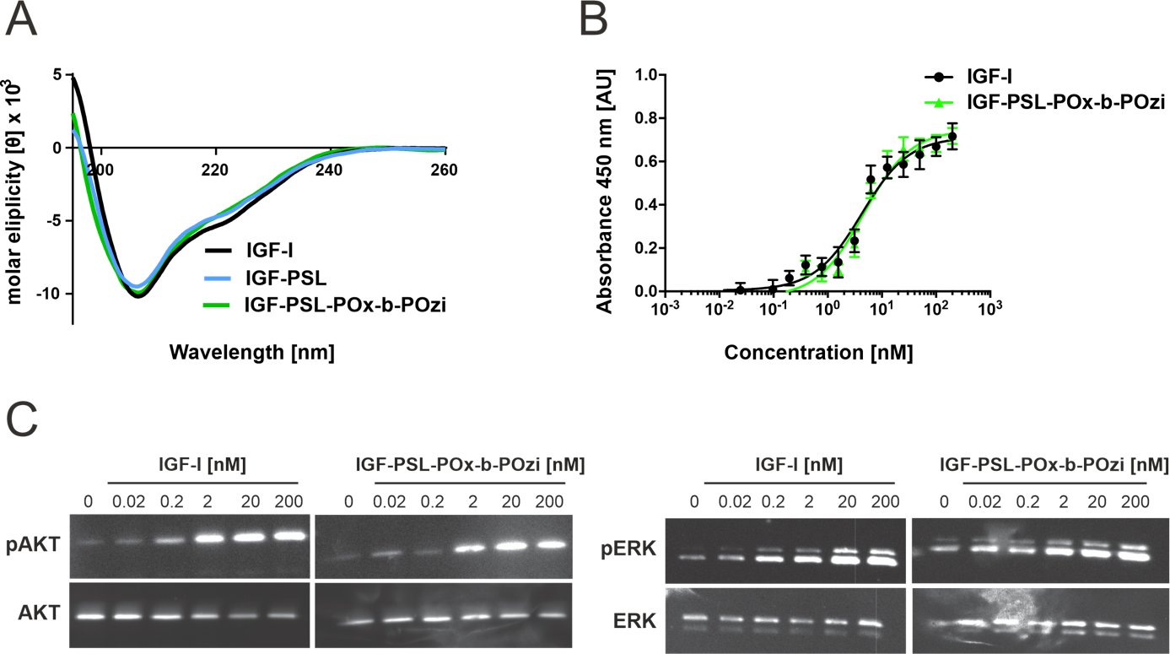
Figure 4: Structural and functional analysis of IGF-PSL-POx-b-POzi conjugate. (A) CD spectra of IGF-I, IGF-PSL, IGF-PSL-POx-b-POzi. (B) C2C12 myoblast proliferation assay with IGF-I, IGF-PSL-POx-b-POzi (n=3 biological replicates and n=3 technical replicates) (C) Western blot analysis of AKT and ERK phosphorylation in C2C12 myoblasts after exposure to IGF-I and IGF-PSL-POx-b-POzi.
IGF-PSL-POx-b-POzi (EC₅₀: 4.3 nM; 95 % CI: 3.5 - 5.1 nM) stimulated the growth of C2C12 cells as potent as the commercially available IGF-I (EC₅₀: 4.6 nM; 95 % CI: 4.0 - 5.4 nM). The analyzed downstream signaling of ERK phosphorylation as well as AKT phosphorylation on C2C12 cells showed a concentration dependent induction of ERK and AKT phosphorylation, confirming that the receptor binding sites of IGF-I were not jeopardized during coupling of the PSL and by the amphiphilic POx-b-POzi polymer.
As POx-b-POzi-DBCO forms only transient (shear-thinning and dilution sensitive) hydrogels due to reversible physical interactions, we combined the previously described furan-modified variant (P(MeOx₉₀-co-Fu₁₀)-b-PnPrOzi₁₀₀; P-Fu) and the maleimide-modified variant (P(MeOx₉₀-co-Ma₁₀)-b-PnPrOzi₁₀₀; P-Ma) of the POx polymer (Figure S9) for covalent cross-linking via Diels-Alder chemistry.⁸ IGF-I or IGF-PSL-POx-b-POzi (25 µg/mL) were added to the polymer solution (P-Fu/P-Ma) prior to thermogelation, followed by chemical Diels-Alder mediated cross-linking. To monitor biological performances of IGF-I and its bioconjugate in the presence and absence of MMP-9 (8 nM), supernatant samples were collected after 2, 4, and 6 hours and subsequently analyzed. Direct enzyme-linked immunosorbent assay (ELISA) readout of released IGF-I and IGF-PSL-POx-b-POzi from the hydrogel was not possible as the different constructs with equivalent concentrations displayed strongly differing signals (Figure S10). Therefore, bioactivity of the released construct in comparison to unconjugated IGF-I was performed by WST-1 cell proliferation assay. MMP-9 treated supernatants significantly impacted the stimulation of C2C12 cells for 4h compared to cells, which were treated with supernatants, lacking MMP-9 treatment (Figure 5, S11).

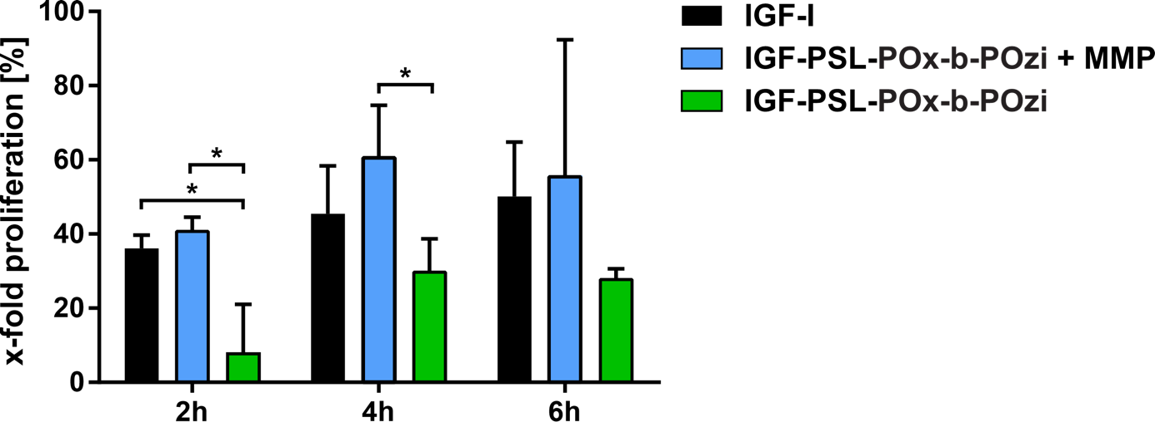
Figure 5: Bioresponsive release of IGF-PSL-POx-b-POzi. C2C12 myoblast proliferation assay with IGF-I, IGF-PSL-POx-b-POzi after release from POx-b-POzi-hydrogels via MMP-9 after different time-points. The asterisk shows statistical significance between the different groups (p < 0.05)
These results indicates that without the presence of MMP-9, the bioconjugate IGF-PSL-POx-b-POzi is retained due to the physical interactions of the POx-b-POzi polymer within the POx-b-POzi hydrogel network. In the presence of MMP-9, hydrogel pores, with pore sizes in the lower 100 nm range (determined by cryo scanning electron microscopy)⁶⁹ allow MMP-9 diffusion (Stokes-Einstein radius of MMP-9: 4.5 nm⁹⁵), cleavage of IGF-PSL-POx-b-POzi and the diffusion of cleaved IGF-I (Stokes-Einstein radius of IGF-I: 1.54 nm⁹⁶) out of the hydrogel. However, since the IGF-PSL-POx-b-POzi is “only” weakly bound to the hydrogel by physical (hydrophobic) interactions, part of the conjugate is still released due to swelling of the hydrogel and diffusion effects. This aspect may be addressed by introducing chemical crosslinking moieties (furan / maleimide) to the POx-b-POzi-DBCO polymer to enable covalent cross-linking within the hydrogel network.
Due to the limited stability of IGF-I at physiological pH values (buffer for MMP-activity according to manufacturer’s manual, Merck KGaA), IGF release was restricted to 6 h in this study.⁹⁷ However, conjugation of IGF-I to hydrophilic polymers such as PEG resulted into prolonged serum stability of IGF-I.⁴⁶ This behaviour might also apply for conjugation with POx within the POx-b-POzi hydrogel network and should be investigated in future studies.
To assess the influence of IGF-PSL-POx-b-POzi on the printability and crosslinking kinetics, preliminary rheological experiments were performed. All the investigated samples remained liquid at 5 °C. Increased temperature to 37 °C induced the rapid thermogelation followed by Diels-Alder crosslinking for the samples containing both crosslinking polymers (P-Fu/P-Ma). The incorporation of IGF-PSL-POx-b-POzi did not affect either the thermogelation, shear thinning and recovery after printing or the crosslinking reaction as assessed by rheological analysis (Figure 6A, S13, S14).
To illustrate the performances of the described POx-b-POzi thermogelling hydrogel system for 3D bioprinting application, we labeled IGF-PSL-POx-b-POzi with the fluorescent dye Atto 488, using amine-reactive linker chemistry for visualization within the P-Fu/P-Ma solution. A second P-Fu/P-Ma solution was modified with Texas RedTM C₂ maleimide using Diels-Alder chemistry. As proof of concept, we printed two separate rings consisting of the two hydrogel batches using an extrusion 3D printing setup (Figure 6B, C, Figure S12A, B). Only one of the compartments contained the IGF-PSL-POx-b-POzi conjugate. Both types of hydrogels were successfully printed and were stored at least 5 h in buffer (PBS, pH 7.5) solution. The distribution of the IGF-PSL-POx-b-POzi as well as Texas RedTM was qualitatively analyzed using fluorescence microscopy. After 5 h of incubation, the printed structures showed good shape fidelity and both IGF-PSL-POx-b-POzi and Texas RedTM were located and visible in their respective printed POx-b-POzi hydrogel compartment (Figure 6D, E and S12C, D). This result indicates that IGF-I can be easily printed in a defined 3D construct with spatial control within the hydrogel structure. Furthermore, it shows that the addition of IGF-PSL-POx-b-POzi does not interfere with the physical characteristics as well as the chemical cross-linking (Diels-Alder) of the hydrogel platform.

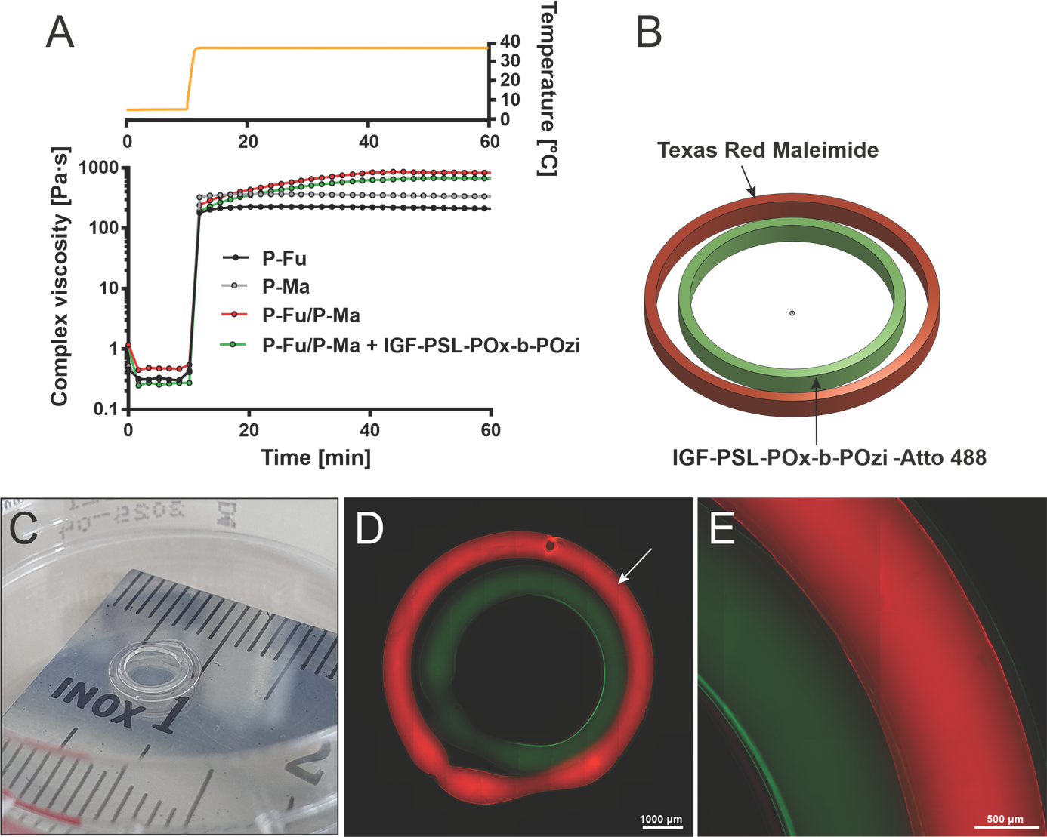Figure 6: 3D printing of IGF-PSL-POx-b-POzi (A) Crosslinking of hydrogels in oscillatory mode (complex viscosity as a function of time) for 10 minutes at 5 °C followed by 60 minutes at 37 °C (amplitude: 0.5%, angular frequency: 10 rad/s, polymer concentration: 25 wt.% and IGF-PSL-POx-b-POzi: 25 µg/mL). (B) 3D model of the printed construct. The model was created by onshape® (Boston, MA 02210) (C) Image of printed POx hydrogel construct. (D-E) Fluorescence images of printed POx constructs after 5 h in PBS. Incorporated IGF-PSL-POx-b-POzi (green) was visualized via NHS-labelling with NHS Alexa FluorTM 488. For the visualization of the outer ring P-Fu was functionalized with Texas Red C2 MaleimideTM (red) prior to printing.
Our IGF-I based POx-b-POzi hydrogel system principally enables individualized, and patient-specific manufacturing within a predefined IGF-I location within the construct architecture (Figure 6).
In the future the bioresponsive IGF-I modified biomaterial/bioink platform may be used to create more complex drug-release profiles customized for the formation of bulk or surface gradients or co-application of different growth factors due to the printing of sophisticated 3D structures and/or spatially separated compartments. Bioresponsive IGF-I release (and combination thereof) may be further tailored with the use of various PSLs to induce spatially definitive cellular responses in generating tissues.
Potential therapeutic applications of such a hydrogel system are within the area of bioresponsive wound sealants that enable the targeted growth factor release at the incision site due to an excess of MMPs.⁹⁸⁻¹⁰⁰ Another potential application is the use of the POx-b-POzi hydrogel system for the regeneration of cartilage tissue. Cellular approaches such as the administration of chondrocytes or stem cells remain challenging and often need to be supported by external growth factors.¹⁰¹ Thus, encapsulation of IGF-I has been frequently performed in hydrogel systems to stimulate chondral repair^{63, 102-103} A localized and bioresponsive delivery of IGF-I in personalized bioprinted construct may be thus suitable to enhance IGF-I biological performances for cartilage formation.
In an effort to address cell adhesion and migration within the POx-b-POzi hydrogel system, incorporation of MMP cleavable linkers and RGD sequences for maturation of cells within the hydrogel matrix and in vivo characterization of bioresponsive IGF-I release is part of ongoing research.
Conclusion
3D printing has emerged as a promising tool to deposit materials with high shape control. In this study, we developed a 3D bioprintable hydrogel system for the bioresponsive release of the anabolic growth factor IGF-I by combining enzymatic and biorthogonal conjugation techniques. The coupling of the thermoresponsive POx-b-POzi polymer to IGF-I did not impair its bioactivity. Incorporation of the protein conjugate into POx-b-POzi hydrogels enabled bioresponsive release of IGF-I after the addition of MMP-9 as an external stimulus, did not impair the rheological properties of the hydrogel system and showed high shape fidelity after 3D-printing.
In general, the herein presented POx-b-POzi hydrogel platform provides a high degree of flexibility through the exchange of individual or multiple components (e. g. therapeutic protein, protease sensitive sequence) and enables future manufacture of complex 3D architectures with release of the bioactive molecule linked to the activity of matrix metalloproteinases in tissue engineering applications including wound healing and cartilage repair.
Acknowledgement
We thank Dr. Juliane Adelmann for MALDI-MS analysis. The authors would like to gratefully acknowledge support by the Deutsche Forschungsgemeinschaft (DFG, German Research Foundation)-project number 326998133-TRR225 (subprojects A03).

Declarations of interest
The authors declare no conflict of interest.
Credit Author Statement
M.B.: Methodology, Visualization, Validation, Data analysis, Investigation, Writing – Original Draft. L.H. Methodology, Visualization, Validation, Data analysis, Investigation, Writing – Original Draft.
A.H.C.H: Methodology, Visualization, Data analysis, Investigation, Writing – Editing
N.H.: Methodology, Visualization, Validation, Data analysis, Investigation, Writing – Editing.
H.S. Validation, Conceptualization, Writing – Reviewing & Editing
L.M.: Validation, Project administration, Resources, Visualization, Conceptualization, Writing -Reviewing & Editing, Supervision, Funding acquisition.
R.L.: Validation, Resources, Conceptualization, Writing -Reviewing & Editing, Funding acquisition.
M.G. Project administration, Methodology, Visualization, Validation, Data analysis, Investigation, Writing – Original Draft.
T.L.: Validation, Project administration, Resources, Visualization, Conceptualization, Writing – Original Draft, Writing -Reviewing & Editing, Supervision, Funding acquisition
References
1. Konta, A. A.; García-Piña, M.; Serrano, D. R., Personalised 3D Printed Medicines: Which Techniques and Polymers Are More Successful? Bioengineering 2017, 4 (4), 79.
2. Bayindir-Buchhalter, I.; Göbel, U.; Stimson, L., Biofabrication, Biomedical Devices, Nanomedicine, and Tissue Engineering – Advanced Materials in Healthcare. Advanced Healthcare Materials 2018, 7 (1), 1701399.
3. Groll, J.; Burdick, J. A.; Cho, D. W.; Derby, B.; Gelinsky, M.; Heilshorn, S. C.; Jüngst, T.; Malda, J.; Mironov, V. A.; Nakayama, K.; Ovsianikov, A.; Sun, W.; Takeuchi, S.; Yoo, J. J.; Woodfield, T. B. F., A definition of bioinks and their distinction from biomaterial inks. Biofabrication 2018, 11 (1), 013001.
4. Levato, R.; Jungst, T.; Scheuring, R. G.; Blunk, T.; Groll, J.; Malda, J., From Shape to Function: The Next Step in Bioprinting. Advanced Materials 2020, 32 (12), 1906423.
5. Stichler, S.; Jungst, T.; Schamel, M.; Zilkowski, I.; Kuhlmann, M.; Böck, T.; Blunk, T.; Teßmar, J.; Groll, J., Thiol-ene Clickable Poly(glycidol) Hydrogels for Biofabrication. Ann Biomed Eng 2017, 45 (1), 273-285.
6. Bertlein, S.; Brown, G.; Lim, K. S.; Jungst, T.; Boeck, T.; Blunk, T.; Tessmar, J.; Hooper, G. J.; Woodfield, T. B. F.; Groll, J., Thiol-Ene Clickable Gelatin: A Platform Bioink for Multiple 3D Biofabrication Technologies. Adv Mater 2017, 29 (44).
7. Farrugia, B. L.; Kempe, K.; Schubert, U. S.; Hoogenboom, R.; Dargaville, T. R., Poly(2-oxazoline) Hydrogels for Controlled Fibroblast Attachment. Biomacromolecules 2013, 14 (8), 2724-2732.
8. Abasalizadeh, F.; Moghaddam, S. V.; Alizadeh, E.; akbari, E.; Kashani, E.; Fazljou, S. M. B.; Torbati, M.; Akbarzadeh, A., Alginate-based hydrogels as drug delivery vehicles in cancer treatment and their applications in wound dressing and 3D bioprinting. Journal of Biological Engineering 2020, 14 (1), 8.
9. Lim, K. S.; Schon, B. S.; Mekhileri, N. V.; Brown, G. C. J.; Chia, C. M.; Prabakar, S.; Hooper, G. J.; Woodfield, T. B. F., New Visible-Light Photoinitiating System for Improved Print Fidelity in Gelatin-Based Bioinks. ACS Biomater Sci Eng 2016, 2 (10), 1752-1762.
10. Ward, M. A.; Georgiou, T. K., Thermoresponsive Polymers for Biomedical Applications. Polymers 2011, 3 (3), 1215-1242.
11. Liu, M.; Zeng, X.; Ma, C.; Yi, H.; Ali, Z.; Mou, X.; Li, S.; Deng, Y.; He, N., Injectable hydrogels for cartilage and bone tissue engineering. Bone Research 2017, 5 (1), 17014.
12. Chatterjee, S.; Hui, P. C.-l.; Kan, C.-w., Thermoresponsive Hydrogels and Their Biomedical Applications: Special Insight into Their Applications in Textile Based Transdermal Therapy. Polymers 2018, 10 (5), 480.
13. Klouda, L., Thermoresponsive hydrogels in biomedical applications: A seven-year update. European Journal of Pharmaceutics and Biopharmaceutics 2015, 97, 338-349.
14. Contessi, N.; Altomare, L.; Filipponi, A.; Farè, S., Thermo-responsive properties of methylcellulose hydrogels for cell sheet engineering. Materials Letters 2017, 207, 157-160.
15. Miguel, S. P.; Ribeiro, M. P.; Brancal, H.; Coutinho, P.; Correia, I. J., Thermoresponsive chitosan–agarose hydrogel for skin regeneration. Carbohydrate Polymers 2014, 111, 366-373.
16. Khoeini, R.; Nosrati, H.; Akbarzadeh, A.; Eftekhari, A.; Kavetskyy, T.; Khalilov, R.; Ahmadian, E.; Nasibova, A.; Datta, P.; Roshangar, L.; Deluca, D. C.; Davaran, S.; Cucchiarini, M.; Ozbolat, I. T., Natural and Synthetic Bioinks for 3D Bioprinting. Advanced NanoBiomed Research 2021, 1 (8), 2000097.
17. Morgan, F. L. C.; Moroni, L.; Baker, M. B., Dynamic Bioinks to Advance Bioprinting. Advanced Healthcare Materials 2020, 9 (15), 1901798.
18. Pitto-Barry, A.; Barry, N. P. E., Pluronic® block-copolymers in medicine: from chemical and biological versatility to rationalisation and clinical advances. Polymer Chemistry 2014, 5 (10), 3291-3297.
19. Batrakova, E. V.; Kabanov, A. V., Pluronic block copolymers: Evolution of drug delivery concept from inert nanocarriers to biological response modifiers. Journal of Controlled Release 2008, 130 (2), 98-106.
20. Schmolka, I. R., A review of block polymer surfactants. Journal of the American Oil Chemists' Society 1977, 54 (3), 110-116.
21. Bodratti, A. M.; Alexandridis, P., Formulation of Poloxamers for Drug Delivery. Journal of Functional Biomaterials 2018, 9 (1), 11.
22. Schlaad, H.; Diehl, C.; Gress, A.; Meyer, M.; Demirel, A. L.; Nur, Y.; Bertin, A., Poly(2-oxazoline)s as Smart Bioinspired Polymers. Macromolecular Rapid Communications 2010, 31 (6), 511-525.
23. Varanaraja, Z.; Kim, J.; Becer, C. R., Poly(2-oxazine)s: A comprehensive overview of the polymer structures, physical properties and applications. European Polymer Journal 2021, 147, 110299.
24. Bloksma, M. M.; Paulus, R. M.; van Kuringen, H. P. C.; van der Woerdt, F.; Lambermont-Thijs, H. M. L.; Schubert, U. S.; Hoogenboom, R., Thermoresponsive Poly(2-oxazine)s. Macromolecular Rapid Communications 2012, 33 (1), 92-96.
25. Lorson, T.; Lübtow, M. M.; Wegener, E.; Haider, M. S.; Borova, S.; Nahm, D.; Jordan, R.; Sokolski-Papkov, M.; Kabanov, A. V.; Luxenhofer, R., Poly(2-oxazoline)s based biomaterials: A comprehensive and critical update. Biomaterials 2018, 178, 204-280.
26. Lübtow, M. M.; Hahn, L.; Haider, M. S.; Luxenhofer, R., Drug Specificity, Synergy and Antagonism in Ultrahigh Capacity Poly(2-oxazoline)/Poly(2-oxazine) based Formulations. J Am Chem Soc 2017, 139 (32), 10980-10983.
27. Lübtow, M. M.; Haider, M. S.; Kirsch, M.; Klisch, S.; Luxenhofer, R., Like Dissolves Like? A Comprehensive Evaluation of Partial Solubility Parameters to Predict Polymer-Drug Compatibility in Ultrahigh Drug-Loaded Polymer Micelles. Biomacromolecules 2019, 20 (8), 3041-3056.
28. Lübtow, M. M.; Nelke, L. C.; Seifert, J.; Kühnemundt, J.; Sahay, G.; Dandekar, G.; Nietzer, S. L.; Luxenhofer, R., Drug induced micellization into ultra-high capacity and stable curcumin nanoformulations: Physico-chemical characterization and evaluation in 2D and 3D in vitro models. J Control Release 2019, 303, 162-180.
29. Hahn, D.; Sonntag, J. M.; Lück, S.; Maitz, M. F.; Freudenberg, U.; Jordan, R.; Werner, C., Poly(2-alkyl-2-oxazoline)-Heparin Hydrogels—Expanding the Physicochemical Parameter Space of Biohybrid Materials. Advanced Healthcare Materials n/a (n/a), 2101327.
30. He, Z.; Wan, X.; Schulz, A.; Bludau, H.; Dobrovolskaia, M. A.; Stern, S. T.; Montgomery, S. A.; Yuan, H.; Li, Z.; Alakhova, D.; Sokolsky, M.; Darr, D. B.; Perou, C. M.; Jordan, R.; Luxenhofer, R.; Kabanov, A. V., A high capacity polymeric micelle of paclitaxel: Implication of high dose drug therapy to safety and in vivo anti-cancer activity. Biomaterials 2016, 101, 296-309.
31. Hwang, D.; Vinod, N.; Skoczen, S. L.; Ramsey, J. D.; Snapp, K. S.; Montgomery, S. A.; Wang, M.; Lim, C.; Frank, J. E.; Sokolsky-Papkov, M.; Li, Z.; Yuan, H.; Stern, S. T.; Kabanov, A. V., Bioequivalence assessment of high-capacity polymeric micelle nanoformulation of paclitaxel and Abraxane® in rodent and non-human primate models using a stable isotope tracer assay. Biomaterials 2021, 278, 121140.
32. Moreadith, R. W.; Viegas, T. X.; Bentley, M. D.; Harris, J. M.; Fang, Z.; Yoon, K.; Dizman, B.; Weimer, R.; Rae, B. P.; Li, X.; Rader, C.; Standaert, D.; Olanow, W., Clinical development of a poly(2-oxazoline) (POZ) polymer therapeutic for the treatment of Parkinson’s disease – Proof of concept of POZ as a versatile polymer platform for drug development in multiple therapeutic indications. European Polymer Journal 2017, 88, 524-552.
33. Olanow, C. W.; Standaert, D. G.; Kieburtz, K.; Viegas, T. X.; Moreadith, R., Once-Weekly Subcutaneous Delivery of Polymer-Linked Rotigotine (SER-214) Provides Continuous Plasma Levels in Parkinson's Disease Patients. Movement Disorders 2020, 35 (6), 1055-1061.
34. Tong, J.; Luxenhofer, R.; Yi, X.; Jordan, R.; Kabanov, A. V., Protein Modification with Amphiphilic Block Copoly(2-oxazoline)s as a New Platform for Enhanced Cellular Delivery. Molecular Pharmaceutics 2010, 7 (4), 984-992.
35. Tong, J.; Yi, X.; Luxenhofer, R.; Banks, W. A.; Jordan, R.; Zimmerman, M. C.; Kabanov, A. V., Conjugates of superoxide dismutase 1 with amphiphilic poly(2-oxazoline) block copolymers for enhanced brain delivery: synthesis, characterization and evaluation in vitro and in vivo. Molecular pharmaceutics 2013, 10 (1), 360-377.
36. Hahn, L.; Karakaya, E.; Zorn, T.; Sochor, B.; Maier, M.; Stahlhut, P.; Forster, S.; Fischer, K.; Seiffert, S.; Pöppler, A.-C.; Detsch, R.; Luxenhofer, R., An Inverse Thermogelling Bioink Based on an ABA-Type Poly(2-oxazoline) Amphiphile. Biomacromolecules 2021, 22 (7), 3017-3027.
37. Lorson, T.; Jaksch, S.; Lübtow, M. M.; Jüngst, T.; Groll, J.; Lühmann, T.; Luxenhofer, R., A Thermogelling Supramolecular Hydrogel with Sponge-Like Morphology as a Cytocompatible Bioink. Biomacromolecules 2017, 18 (7), 2161-2171.
38. Hahn, L.; Beudert, M.; Gutmann, M.; Keßler, L.; Stahlhut, P.; Fischer, L.; Karakaya, E.; Lorson, T.; Thievessen, I.; Detsch, R.; Lühmann, T.; Luxenhofer, R., From Thermogelling Hydrogels toward Functional Bioinks: Controlled Modification and Cytocompatible Crosslinking. Macromol Biosci 2021, e2100122.
39. Koons, G. L.; Mikos, A. G., Progress in three-dimensional printing with growth factors. Journal of Controlled Release 2019, 295, 50-59.
40. Peak, C. W.; Singh, K. A.; Adlouni, M. a.; Chen, J.; Gaharwar, A. K., Printing Therapeutic Proteins in 3D using Nanoengineered Bioink to Control and Direct Cell Migration. Advanced Healthcare Materials 2019, 8 (11), 1801553.
41. Luxenhofer, R.; Han, Y.; Schulz, A.; Tong, J.; He, Z.; Kabanov, A. V.; Jordan, R., Poly(2-oxazoline)s as Polymer Therapeutics. Macromolecular Rapid Communications 2012, 33 (19), 1613-1631.
42. Braun, A. C.; Gutmann, M.; Ebert, R.; Jakob, F.; Gieseler, H.; Lühmann, T.; Meinel, L., Matrix Metalloproteinase Responsive Delivery of Myostatin Inhibitors. Pharmaceutical Research 2017, 34 (1), 58-72.
43. Braun, A. C.; Gutmann, M.; Mueller, T. D.; Lühmann, T.; Meinel, L., Bioresponsive release of insulin-like growth factor-I from its PEGylated conjugate. Journal of Controlled Release 2018, 279, 17-28.
44. Alconcel, S. N. S.; Baas, A. S.; Maynard, H. D., FDA-approved poly(ethylene glycol)–protein conjugate drugs. Polymer Chemistry 2011, 2 (7), 1442-1448.
45. Kolate, A.; Baradia, D.; Patil, S.; Vhora, I.; Kore, G.; Misra, A., PEG — A versatile conjugating ligand for drugs and drug delivery systems. Journal of Controlled Release 2014, 192, 67-81.
46. Braun, A. C.; Gutmann, M.; Mueller, T. D.; Lühmann, T.; Meinel, L., Bioresponsive release of insulin-like growth factor-I from its PEGylated conjugate. J Control Release 2018, 279, 17-28.
47. Rinderknecht, E.; Humbel, R. E., The amino acid sequence of human insulin-like growth factor I and its structural homology with proinsulin. J Biol Chem 1978, 253 (8), 2769-76.
48. Breil, T.; Kneppo, C.; Bettendorf, M.; German, I. G. F. I. D. S. G.; Muller, H. L.; Kapelari, K.; Schnabel, D.; Woelfle, J., Sequential measurements of IGF-I serum concentrations in adolescents with Laron syndrome treated with recombinant human IGF-I (rhIGF-I). J Pediatr Endocrinol Metab 2018, 31 (8), 895-902.
49. Boro, H.; Rahman, S. H.; Khatiwada, S.; Alam, S.; Khadgawat, R., Laron syndrome: An experience of treatment of two cases. Journal of Clinical and Translational Endocrinology: Case Reports 2021, 19, 100076.
50. Chernausek, S. D.; Backeljauw, P. F.; Frane, J.; Kuntze, J.; Underwood, L. E., Long-Term Treatment with Recombinant Insulin-Like Growth Factor (IGF)-I in Children with Severe IGF-I Deficiency due to Growth Hormone Insensitivity. The Journal of Clinical Endocrinology & Metabolism 2007, 92 (3), 902-910.
51. Hansson, H. A.; Dahlin, L. B.; Danielsen, N.; Fryklund, L.; Nachemson, A. K.; Polleryd, P.; Rozell, B.; Skottner, A.; Stemme, S.; Lundborg, G., Evidence indicating trophic importance of IGF-I in regenerating peripheral nerves. Acta Physiol Scand 1986, 126 (4), 609-14.
52. HANSSON, H. A.; DAHLIN, L. B.; DANIELSEN, N.; FRYKLUND, L.; NACHEMSON, A. K.; POLLERYD, P.; ROZELL, B.; SKOTTNER, A.; STEMME, S.; LUNDBORG, G., Evidence indicating trophic importance of IGF-1 in regenerating peripheral nerves. Acta Physiologica Scandinavica 1986, 126 (4), 609-614.
53. Osher, E.; Macaulay, V. M., Therapeutic Targeting of the IGF Axis. Cells 2019, 8 (8), 895.
54. Jones, J. I.; Clemmons, D. R., Insulin-Like Growth Factors and Their Binding Proteins: Biological Actions*. Endocrine Reviews 1995, 16 (1), 3-34.
55. Stiles, C. D.; Capone, G. T.; Scher, C. D.; Antoniades, H. N.; Van Wyk, J. J.; Pledger, W. J., Dual control of cell growth by somatomedins and platelet-derived growth factor. Proceedings of the National Academy of Sciences 1979, 76 (3), 1279-1283.
56. Cittadini, A.; Monti, M. G.; Petrillo, V.; Esposito, G.; Imparato, G.; Luciani, A.; Urciuolo, F.; Bobbio, E.; Natale, C. F.; Saccà, L.; Netti, P. A., Complementary therapeutic effects of dual delivery of insulin-like growth factor-1 and vascular endothelial growth factor by gelatin microspheres in experimental heart failure. European Journal of Heart Failure 2011, 13 (12), 1264-1274.
57. Rosenfeld, R. G., IGF-I therapy in growth disorders. Eur J Endocrinol 2007, 157 Suppl 1, S57-60.
58. Germershaus, O.; Schultz, I.; Lühmann, T.; Beck-Broichsitter, M.; Högger, P.; Meinel, L., Insulin-like growth factor-I aerosol formulations for pulmonary delivery. European Journal of Pharmaceutics and Biopharmaceutics 2013, 85 (1), 61-68.
59. Luginbuehl, V.; Wenk, E.; Koch, A.; Gander, B.; Merkle, H. P.; Meinel, L., Insulin-like growth factor I-releasing alginate-tricalciumphosphate composites for bone regeneration. Pharm Res 2005, 22 (6), 940-50.
60. Luginbuehl, V.; Zoidis, E.; Meinel, L.; von Rechenberg, B.; Gander, B.; Merkle, H. P., Impact of IGF-I release kinetics on bone healing: a preliminary study in sheep. Eur J Pharm Biopharm 2013, 85 (1), 99-106.
61. Meinel, L.; Illi, O. E.; Zapf, J.; Malfanti, M.; Peter Merkle, H.; Gander, B., Stabilizing insulin-like growth factor-I in poly(D,L-lactide-co-glycolide) microspheres. J Control Release 2001, 70 (1-2), 193-202.
62. Meinel, L.; Zoidis, E.; Zapf, J.; Hassa, P.; Hottiger, M. O.; Auer, J. A.; Schneider, R.; Gander, B.; Luginbuehl, V.; Bettschart-Wolfisberger, R.; Illi, O. E.; Merkle, H. P.; von Rechenberg, B., Localized insulin-like growth factor I delivery to enhance new bone formation. Bone 2003, 33 (4), 660-72.
63. Uebersax, L.; Merkle, H. P.; Meinel, L., Insulin-like growth factor I releasing silk fibroin scaffolds induce chondrogenic differentiation of human mesenchymal stem cells. J Control Release 2008, 127 (1), 12-21.
64. Wenk, E.; Wandrey, A. J.; Merkle, H. P.; Meinel, L., Silk fibroin spheres as a platform for controlled drug delivery. J Control Release 2008, 132 (1), 26-34.
65. Feng, J.; Wu, Y.; Chen, W.; Li, J.; Wang, X.; Chen, Y.; Yu, Y.; Shen, Z.; Zhang, Y., Sustained release of bioactive IGF-1 from a silk fibroin microsphere-based injectable alginate hydrogel for the treatment of myocardial infarction. Journal of Materials Chemistry B 2020, 8 (2), 308-315.
66. Witte, H.; Seeliger, W., Simple Synthesis of 2-Substituted 2-Oxazolines and 5,6-Dihydro-4H-1,3-oxazines. Angewandte Chemie International Edition in English 1972, 11 (4), 287-288.
67. Hahn, L.; Lübtow, M. M.; Lorson, T.; Schmitt, F.; Appelt-Menzel, A.; Schobert, R.; Luxenhofer, R., Investigating the Influence of Aromatic Moieties on the Formulation of Hydrophobic Natural Products and Drugs in Poly(2-oxazoline)-Based Amphiphiles. Biomacromolecules 2018, 19 (7), 3119-3128.
68. Hofmann, J.; Fayez, S.; Scheiner, M.; Hoffmann, M.; Oerter, S.; Appelt-Menzel, A.; Maher, P.; Maurice, T.; Bringmann, G.; Decker, M., Sterubin: Enantioresolution and Configurational Stability, Enantiomeric Purity in Nature, and Neuroprotective Activity in Vitro and in Vivo. Chemistry 2020, 26 (32), 7299-7308.
69. Hahn, L.; Beudert, M.; Gutmann, M.; Keßler, L.; Stahlhut, P.; Fischer, L.; Karakaya, E.; Lorson, T.; Thievessen, I.; Detsch, R.; Lühmann, T.; Luxenhofer, R., From Thermogelling Hydrogels toward Functional Bioinks: Controlled Modification and Cytocompatible Crosslinking. Macromolecular Bioscience n/a (n/a), 2100122.
70. Cooke, R. M.; Harvey, T. S.; Campbell, I. D., Solution structure of human insulin-like growth factor 1: a nuclear magnetic resonance and restrained molecular dynamics study. Biochemistry 1991, 30 (22), 5484-5491.
71. Vanquelef, E.; Simon, S.; Marquant, G.; Garcia, E.; Klimerak, G.; Delepine, J. C.; Cieplak, P.; Dupradeau, F. Y., R.E.D. Server: a web service for deriving RESP and ESP charges and building force field libraries for new molecules and molecular fragments. Nucleic Acids Res 2011, 39 (Web Server issue), W511-7.
72. Maier, J. A.; Martinez, C.; Kasavajhala, K.; Wickstrom, L.; Hauser, K. E.; Simmerling, C., ff14SB: Improving the Accuracy of Protein Side Chain and Backbone Parameters from ff99SB. Journal of Chemical Theory and Computation 2015, 11 (8), 3696-3713.
73. Jorgensen, W. L.; Chandrasekhar, J.; Madura, J. D.; Impey, R. W.; Klein, M. L., Comparison of simple potential functions for simulating liquid water. The Journal of Chemical Physics 1983, 79 (2), 926-935.
74. Case, D. A.; Darden, T. A.; Cheatham, T. E., 3rd; Simmerling, C.; Wang, J.; Duke, R. E.; Luo, R.; Crowley, M.; Walker, R. C.; Zhang, W.; Merz, K. M.; Wang, B.; Hayik, S.; Roitberg, A.; Seabra, G.; Kolossváry, I.; Wong, K. F.; Paesani, F.; Vanicek, J.; Wu, X.; Brozell, S. R.; Steinbrecher, T.; Gohlke, H.; Yang, L.; Tan, C.; Mongan, J.; Hornak, V.; Cui, G.; Mathews, D. H.; Seetin, M. G.; Sagui, C.; Babin, V.; Kollman, J. W. Amber20, University of California: San Francisco, 2020.
75. Salomon-Ferrer, R.; Götz, A. W.; Poole, D.; Le Grand, S.; Walker, R. C., Routine Microsecond Molecular Dynamics Simulations with AMBER on GPUs. 2. Explicit Solvent Particle Mesh Ewald. Journal of Chemical Theory and Computation 2013, 9 (9), 3878-3888.
76. Götz, A. W.; Williamson, M. J.; Xu, D.; Poole, D.; Le Grand, S.; Walker, R. C., Routine Microsecond Molecular Dynamics Simulations with AMBER on GPUs. 1. Generalized Born. Journal of Chemical Theory and Computation 2012, 8 (5), 1542-1555.
77. Ryckaert, J.-P.; Ciccotti, G.; Berendsen, H. J. C., Numerical integration of the cartesian equations of motion of a system with constraints: molecular dynamics of n-alkanes. Journal of Computational Physics 1977, 23 (3), 327-341.
78. Miyamoto, S.; Kollman, P. A., Settle: An analytical version of the SHAKE and RATTLE algorithm for rigid water models. Journal of Computational Chemistry 1992, 13 (8), 952-962.
79. Söldner, C. A.; Sticht, H.; Horn, A. H. C., Role of the N-terminus for the stability of an amyloid-β fibril with three-fold symmetry. PLOS ONE 2017, 12 (10), e0186347.
80. Humphrey, W.; Dalke, A.; Schulten, K., VMD: Visual molecular dynamics. Journal of Molecular Graphics 1996, 14 (1), 33-38.
81. Lee, H.; Park, T. G., Preparation and characterization of mono-PEGylated epidermal growth factor: evaluation of in vitro biologic activity. Pharm Res 2002, 19 (6), 845-51.
82. Dozier, J. K.; Distefano, M. D., Site-Specific PEGylation of Therapeutic Proteins. Int J Mol Sci 2015, 16 (10), 25831-64.
83. Cascieri, M. A.; Chicchi, G. G.; Applebaum, J.; Hayes, N. S.; Green, B. G.; Bayne, M. L., Mutants of human insulin-like growth factor I with reduced affinity for the type 1 insulin-like growth factor receptor. Biochemistry 1988, 27 (9), 3229-3233.
84. Sitar, T.; Popowicz, G. M.; Siwanowicz, I.; Huber, R.; Holak, T. A., Structural basis for the inhibition of insulin-like growth factors by insulin-like growth factor-binding proteins. Proceedings of the National Academy of Sciences 2006, 103 (35), 13028-13033.
85. Bayne, M. L.; Applebaum, J.; Underwood, D.; Chicchi, G. G.; Green, B. G.; Hayes, N. S.; Cascieri, M. A., The C Region of Human Insulin-like Growth Factor (IGF) I Is Required for High Affinity Binding to the Type 1 IGF Receptor. Journal of Biological Chemistry 1989, 264 (19), 11004-11008.
86. Schense, J. C.; Hubbell, J. A., Cross-linking exogenous bifunctional peptides into fibrin gels with factor XIIIa. Bioconjug Chem 1999, 10 (1), 75-81.
87. Ritzer, J.; Lühmann, T.; Rode, C.; Pein-Hackelbusch, M.; Immohr, I.; Schedler, U.; Thiele, T.; Stübinger, S.; Rechenberg, B. v.; Waser-Althaus, J.; Schlottig, F.; Merli, M.; Dawe, H.; Karpíšek, M.; Wyrwa, R.; Schnabelrauch, M.; Meinel, L., Diagnosing peri-implant disease using the tongue as a 24/7 detector. Nature Communications 2017, 8 (1), 264.
88. Nagase, H.; Fields, G. B., Human matrix metalloproteinase specificity studies using collagen sequence-based synthetic peptides. Biopolymers 1996, 40 (4), 399-416.
89. Waterhouse, A. M.; Procter, J. B.; Martin, D. M. A.; Clamp, M.; Barton, G. J., Jalview Version 2—a multiple sequence alignment editor and analysis workbench. Bioinformatics 2009, 25 (9), 1189-1191.
90. Pettersen, E. F.; Goddard, T. D.; Huang, C. C.; Couch, G. S.; Greenblatt, D. M.; Meng, E. C.; Ferrin, T. E., UCSF Chimera—A visualization system for exploratory research and analysis. Journal of Computational Chemistry 2004, 25 (13), 1605-1612.
91. Lühmann, T.; Schmidt, M.; Leiske, M. N.; Spieler, V.; Majdanski, T. C.; Grube, M.; Hartlieb, M.; Nischang, I.; Schubert, S.; Schubert, U. S.; Meinel, L., Site-Specific POxylation of Interleukin-4. ACS Biomaterials Science & Engineering 2017, 3 (3), 304-312.
92. Hauptstein, N.; Pouyan, P.; Kehrein, J.; Dirauf, M.; Driessen, M. D.; Raschig, M.; Licha, K.; Gottschaldt, M.; Schubert, U. S.; Haag, R.; Meinel, L.; Sotriffer, C.; Lühmann, T., Molecular Insights into Site-Specific Interferon-α2a Bioconjugates Originated from PEG, LPG, and PEtOx. Biomacromolecules 2021, 22 (11), 4521-4534.
93. Ahrens, D.; Koch, A. E.; Pope, R. M.; Stein-Picarella, M.; Niedbala, M. J., Expression of matrix metalloproteinase 9 (96-kd gelatinase B) in human rheumatoid arthritis. Arthritis Rheum 1996, 39 (9), 1576-87.
94. Gauguin, L.; Delaine, C.; Alvino, C. L.; McNeil, K. A.; Wallace, J. C.; Forbes, B. E.; De Meyts, P., Alanine Scanning of a Putative Receptor Binding Surface of Insulin-like Growth Factor-I*. Journal of Biological Chemistry 2008, 283 (30), 20821-20829.
95. Rosenblum, G.; Van den Steen, P. E.; Cohen, S. R.; Grossmann, J. G.; Frenkel, J.; Sertchook, R.; Slack, N.; Strange, R. W.; Opdenakker, G.; Sagi, I., Insights into the structure and domain flexibility of full-length pro-matrix metalloproteinase-9/gelatinase B. Structure 2007, 15 (10), 1227-36.
96. Nauman, J. V.; Campbell, P. G.; Lanni, F.; Anderson, J. L., Diffusion of insulin-like growth factor-I and ribonuclease through fibrin gels. Biophys J 2007, 92 (12), 4444-50.
97. Germershaus, O.; Schultz, I.; Lühmann, T.; Beck-Broichsitter, M.; Högger, P.; Meinel, L., Insulin-like growth factor-I aerosol formulations for pulmonary delivery. Eur J Pharm Biopharm 2013, 85 (1), 61-8.
98. Jee, J. P.; Pangeni, R.; Jha, S. K.; Byun, Y.; Park, J. W., Preparation and in vivo evaluation of a topical hydrogel system incorporating highly skin-permeable growth factors, quercetin, and oxygen carriers for enhanced diabetic wound-healing therapy. International journal of nanomedicine 2019, 14, 5449-5475.
99. Caley, M. P.; Martins, V. L. C.; O'Toole, E. A., Metalloproteinases and Wound Healing. Adv Wound Care (New Rochelle) 2015, 4 (4), 225-234.
100. Garoufalia, Z.; Papadopetraki, A.; Karatza, E.; Vardakostas, D.; Philippou, A.; Kouraklis, G.; Mantas, D., Insulin-like growth factor-I and wound healing, a potential answer to non-healing wounds: A systematic review of the literature and future perspectives. Biomed Rep 2021, 15 (2), 66-66.
101. Cho, H.; Kim, J.; Kim, S.; Jung, Y. C.; Wang, Y.; Kang, B.-J.; Kim, K., Dual delivery of stem cells and insulin-like growth factor-1 in coacervate-embedded composite hydrogels for enhanced cartilage regeneration in osteochondral defects. Journal of Controlled Release 2020, 327, 284-295.
102. Elisseeff, J.; McIntosh, W.; Fu, K.; Blunk, T.; Langer, R., Controlled-release of IGF-I and TGF-β1 in a photopolymerizing hydrogel for cartilage tissue engineering. Journal of Orthopaedic Research 2001, 19 (6), 1098-1104.
103. Mullen, L. M.; Best, S. M.; Ghose, S.; Wardale, J.; Rushton, N.; Cameron, R. E., Bioactive IGF-1 release from collagen-GAG scaffold to enhance cartilage repair in vitro. J Mater Sci Mater Med 2015, 26 (1), 5325.

